

**VALUE CHAIN PROGRAM DESIGN IN**

**THE RWANDAN FRESH VEGETABLE**

**VALUE CHAIN**

*August* 2014

Submitted by Action for Enterprise

Table of Contents

List of Abbreviations 2

Executive Summary 3

1. Introduction 6

2. Value Chain Selection 6

3. Value Chain Program Design Orientation 8

4. Value Chain Analysis and Identification of Market-Based Solutions 9

4.1 Fresh Vegetable Production in Rwanda 9

4.2 Assessment of the End Markets for Fresh Vegetables 11

4.3 Value Chain Market Actors 12

4.3.1 Input Supply Companies and Retailers 14

4.3.2 Producers 15

4.3.3 Traders/ Wholesalers, Including Cooperatives and Exporters 16

4.3.4 Vegetable Retailers 19

4.3.5 Government Agencies 19

4.4 Constraints and Market-based Solutions 20

4.5 Prioritization of Market-based Solutions 23

5. Assessment of Market-based Solutions & Identification of Program Facilitation Activities 24

6. Recommendations and Next Steps 38

6.1 Soliciting Initiatives from MBS Providers (Lead Firms) 38

6.1.1 Using Public Advertisements to Identify Additional Lead Firms 39

6.2 Reviewing Lead Firm Applications and Refining Interventions 40

6.2.1 Using Question Guides to Facilitate Lead Firm Interventions 41

6.2.2 Due Diligence 42

6.3 Structuring Collaboration with Lead Firms 42

6.3.1 Components of Successful MOUs 43

6.3.2 Addendums to MOUs 43

6.3.3 Guidelines on Structuring Financial Support to Lead Firms 44

6.3.4 Lessons Learned in Managing Technical and Financial Support Agreements 45

Acknowledgements 46

APPENDICES 47

Appendix 1: Persons Interviewed in the Fresh Vegetable Value Chain 48

Appendix 2: Summary Presentation of Activities 50

Appendix 3: Illustrative Work Plan for EMIRGE 56

Appendix 4: Draft Invitation for Applications (IFA) 57

Appendix 5: Interview Guide for Lead Firms 62

# List of Abbreviations

AFE Action for Enterprise

EMIRGE Enabling Market Integration through Rural Group Empowerment

FAO Food and Agriculture Organization

FGD Focus Group Discussion

GC Global Communities

Ha Hectares

IFA Invitation for Applications

LF Lead Firm

MBS Market-based Solution

MINAGRI Ministry of Agriculture & Animal Resources

MSME Micro, Small and Medium Enterprise

NAEB National Agriculture Export Development Board

RAB Rwanda Agriculture Board

USAID United States Agency for International Development  
USD United States Dollar

# Executive Summary

In Rwanda, USAID’s EMIRGE program has begun a market-development initiative to promote sustainable impact with farmers and agricultural cooperatives. To support those efforts, Action for Enterprise (AFE) was contracted from April to July 2014 to lead a program design exercise in the vegetable value chain and to build the capacity of EMIRGE’s team to conduct value chain development activities. This report presents the results of the program design exercise for the vegetable value chain.

***Selection Exercise*** – AFE guided the EMIRGE team in selecting a sector within the horticulture value chain with strong growth potential and participation of large numbers of farmers. Focus was narrowed to the vegetable value chain, within horticulture, given the crops can be rotated among other agricultural products which the target farmers are already cultivating. Considered was further narrowing the focus of the vegetable value chain between “fresh for domestic consumptions,” “fresh for export,” and “processed vegetables.” Given the lack of vegetable processing at present, the final value chain selected was the “fresh vegetables” value chain (combing both domestic consumption and export). Of particular focus were vegetables of higher volume including: carrot, onion, tomato, cabbage, eggplant (white and purple) and french beans.

***Orientation –*** AFE conducted a half-day refresher workshop in preparation for the program design exercise for the EMIRGE team. This workshop refreshed the EMIRGE team with the tools and methodologies that combine the strengths of value chain analysis with methods for identifying commercially viable, market-based solutions that promote industry competitiveness and benefits for farmers. A more intensive training was provided during the maize value chain program design in April 2014.

***Value Chain Analysis* –** From May 26 to June 13, AFE with the EMIRGE team, conducted over thirty interviews with market actors in the fresh vegetable sector and other key informants in order to complete a value chain map, assess the end market, understand inter-firm relations and governance structures, and identify constraints in the fresh vegetable value chain.

***Identification, Prioritization and Assessment of Market-Based Solutions* –** The team then identified potential market-based solutions (MBSs) that could address identified constraints and prioritized these MBSs according to their abilities to improve the competitiveness of the targeted value chains and benefit the largest number of small-scale vegetable farmers (also referred to in this report as micro, small, and medium scale enterprises or MSMEs). The shortlisted MBSs were then assessed through additional conversations with MBS providers (also referred to as “Lead Firms”) to identify challenges, incentives, and initiatives for developing the targeted MBSs.

***Identification of Illustrative Program Facilitation Activities*** – Based on input from Lead Firms (LFs), AFE identified illustrative “facilitation activities” that EMIRGE could undertake to support the LFs in implementation of MBSs. This support would build the capacity of the LFs to improve the products, services, market access and support (MBSs) that they provide to vegetable farmers as part of their commercial relationships with them. The prioritized MBSs, targeted LFs, and illustrative LF initiatives (that could be facilitated with EMIRGE technical and cost share support) are summarized in the following tables.

|  |  |
| --- | --- |
| **Market-Based Solution 1** | **Targeted Providers (Lead Firms)** |
| Provision of **information and/or trainings in modern cultivation techniques** to increase yields for vegetable farmers. Information may take the form of trainings, exposure visits, demonstration plot site visits, posters, brochures, leaflets, etc. as determined with providers of the market-based solution. | Seed companies as the primary provider, with distribution of information/ trainings conducted in collaboration with agro-dealers/shops and Agrotech franchises. Pesticide companies can also be a resource for cultivation techniques related to chemical applications. |
| **Illustrative Lead Firm Initiatives** (that could be facilitated with EMIRGE technical and cost share support) | |
| *Initiatives proposed by (and to be implemented by) seed companies included the following:*   * provide information about cultivation of vegetables through additional live radio broadcasts, which allow for farmers to call with pressing questions; * increase distribution of disease photobooklets (such as those prepared by Rwanda Agriculture Board) * promote Farmer Days at demonstration plots and research stations where vegetable trials are undertaken in partnership with the polytechnic universities * provide information in the form of leaflets which address specific problem areas vegetable farmers face for each specific crop * promote Rwanda Agriculture Board’s (RAB) plant clinics to extend outreach to vegetable farmers * educate agro-dealers/shops who in turn provide technical support to vegetable farmers   These activities were proposed by only a few seed companies and are only illustrative. Moving forward, a broader, more comprehensive process of soliciting company initiatives should take place through an Invitation for Applications process, a focus group discussion and/or follow-up interviews with additional seed companies. | |

|  |  |
| --- | --- |
| **Market-Based Solution 2** | **Targeted Providers (Lead Firms)** |
| Provision of **information and/or trainings** to vegetable farmers regarding **how to mitigate vegetable crop** disease (possibly in conjunction with MBS #1 – provision of information/ trainings in modern cultivation techniques) to increase yields for vegetable farmers. | Seed companies as the primary providers, with distribution of information/ trainings conducted in collaboration with agro-dealers/shops and franchises. Pesticide companies can also be a strong partner. |
| **Illustrative Lead Firm Initiatives** (that could be facilitated with EMIRGE technical and cost share support) | |
| *Initiatives proposed by (and to be implemented by) seed companies included the following:*   * provide information about disease mitigation for vegetables through live radio broadcasts, dissemination of RAB photobooklets, demonstrations at research stations and farmer plots, leaflets, and additional plant clinics.   These activities were proposed by only one seed company. Other seed companies may have additional ideas, which can be explored through an Invitation for Applications process, a focus group discussion and/or follow-up interviews with additional seed or pesticide companies. | |

|  |  |
| --- | --- |
| **Market-Based Solution 3** | **Targeted Providers (Lead Firms)** |
| Provision of **information about quality vegetable seed brands and varieties** for vegetable farmers. Information may take the form of exposure visits, demonstration plot site visits, posters, brochures, leaflets, etc. as determined with providers of the market-based solution. | Seed companies as the primary provider, with provision of information conducted in collaboration with agro-dealers/shops and Agrotech franchises. |
| **Illustrative Lead Firm Initiatives** (that could be facilitated with EMIRGE technical and cost share support) | |
| *Initiatives proposed by (and to be implemented by) seed companies included the following:*   * provide information about seed varieties through additional live radio broadcasts, which allow for farmers to call with pressing questions; * promote Farmer Days at demonstration plots and research stations where vegetable trials are undertaken in partnership with the polytechnic universities * provide information in the form of leaflets which highlight a diversity of vegetable varieties and their recommended cultivation practices * educate agro-dealers/shops who in turn provide seed information to vegetable farmers   These activities were proposed by a few seed companies and are therefore illustrative. Moving forward, a broader, more comprehensive process of soliciting company initiatives should take place through an Invitation for Applications process, a focus group discussion and/or follow-up interviews with additional seed companies. | |

|  |  |
| --- | --- |
| **Market-Based Solution 4** | **Targeted Providers (Lead Firms)** |
| **Access to additional varieties of quality vegetable seed** for vegetable farmers. | Seed companies as the primary provider, with access to seed provided in collaboration with agro-dealers/shops and Agrotech franchises. |
| **Illustrative Lead Firm Initiatives** (that could be facilitated with EMIRGE technical and cost share support) | |
| *Initiatives proposed by (and to be implemented by) seed companies included:*   * expand seed distribution systems. * For Agrotech, a seed company with a more developed distribution system, there is a need for more varieties of seed so their franchises do not need to supplement Agrotech seed with as many competitor brands and varieties.   EMIRGE will need to seek more specific information and ideas about initiatives which the seed companies would like support in undertaking. Ideas from seed companies can be sought through an Invitation for Applications process, a focus group discussion and/or follow-up interviews with additional seed companies. | |

|  |  |
| --- | --- |
| **Market-Based Solution 5** | **Targeted Providers (Lead Firms)** |
| Access to irrigation equipment for vegetable farmers who will cultivate marshlands during the dry season (July – September). Equipment refers primarily to water pumps which are most efficient for more than two hectares. Additionally, manual pedal pumps, hoses, watering cans, and other irrigation tools associated with dry season farming may be included. | Irrigation supply companies as the primary provider, with access to irrigation equipment provided in collaboration with agro-dealers/shops. |
| **Illustrative Lead Firm Initiatives** (that could be facilitated with EMIRGE technical and cost share support) | |
| EMIRGE will need to seek more specific information and ideas about initiatives which the irrigation equipment supply/rental companies would like support in undertaking. Ideas from seed companies can be sought also through an Invitation for Applications process, a focus group discussion and/or interviews.  Input supply companies such as Agrotech seed company will be most likely to extend this MBS to improve brand image and increase sales. Other Lead Firms in the irrigation supply business still need to be identified, as do potential Lead Firms in the equipment rental business. EMIRGE can seek interested companies through an Invitation for Applications process, beginning with a public advertisement. This advertisement would help interested companies come forth for further discussions. | |

**Next Steps –** AFE presented EMIRGE with a draft work plan with timeline for implementation. Included in the next steps is inviting Lead Firms to provide more details regarding potential initiatives they would like to undertake (and that EMIRGE might support with technical/financial assistance). This can be done through an “Invitation for Applications” (IFA). A draft is included in this document. Also included is an example public advertisement to solicit collaboration from additional Lead Firms which may not have been contacted during the program design process.

Once activities have been identified and Lead Firms have been diligently vetted, EMIRGE can develop Memorandums of Understanding (MOUs) and technical and cost share agreements with the Lead Firms and begin supporting them in implementation. These tools and methods are discussed during the “Next Steps” session at the end of the report.

# Introduction

In Rwanda, the Enabling Market Integration through Rural Group Empowerment (EMIRGE) program, funded by United States Agency for International Development (USAID) and implemented by Global Communities (GC), has begun developing a market-development program to sustainably support the agricultural cooperatives with which they work. To support those efforts, Action for Enterprise (AFE) was contracted from April to July 2014 to lead a program design exercise for two value chains, and build the capacity of EMIRGE’s team to conduct value chain development activities.

AFE consultants worked with the EMIRGE team to conduct the following program design activities related to vegetables:

* A value chain selection exercise
* A refresher value chain program design orientation and planning session
* An analysis of the fresh vegetable value chain
* An assessment of prioritized market-based solutions that address identified value chain constraints
* Validation of incentives and challenges to market-based solutions
* Identification of potential project facilitation activities
* “Next steps” presentations to the EMIRGE team and GC colleagues

This report focuses on the fresh vegetable value chain in Rwanda (for maize, see report entitled *Value Chain Program Design in the Rwandan Maize Value Chain*.) This report begins with an explanation of the value chain selection. This is followed by a description of the program design exercises carried out. A summary of the program design results is then presented, followed by a discussion of recommendations and next steps.

# Value Chain Selection

As the EMIRGE team works with agricultural production and marketing cooperatives in Rwanda, the team wanted to focus on the horticulture sector, as a complementary sector for the EMIRGE targeted farmers. As horticulture is a broad sector including flowers, fruits, and vegetables, AFE supported the EMIRGE team to narrow the focus. The vegetable sector was selected as these crops fit most appropriately in crop rotation for the targeted farmers.

Within the vegetables sector, the EMIRGE team made an initial list of specific vegetable varieties to consider for further investigation. Among consideration were high volume crops for domestic consumption as well as vegetables with potential for international export. Based on interviews with key informants and review of secondary data, we found these to include the following:

* *High volume vegetables for domestic consumption*: carrot, onion, tomato, cabbage, eggplant (purple/white), french beans
* *Vegetables with potential for export internationally*: french beans, onion, tomato, snow pea, hot pepper, bullet chili, bird’s eye chili, white eggplant

The EMIRGE team next looked to see if there was a difference in the following categories of vegetable:

* Fresh vegetables for domestic consumption
* Fresh vegetables for exports
* Processed vegetables

Interviews with key informants revealed additional information. (See Appendix 1 for complete list of interviews for the entire value chain program design process.)

Regarding vegetable processing, the one known tomato processing plant never fully functioned and has been out of operation for more than two years. No other known vegetable processing companies in Rwanda were identified. As the domestic market for processed vegetables has not been developed, processed vegetables was ruled out as a focus for program design.

Regarding export, a fair amount of onions are exported overland to the Democratic Republic of Congo, from the neighboring northwest region of Rwanda. While it is assumed that vegetables are also exported to neighboring Uganda and Burundi, the Rwandan Government lacks official data quantifying the amount of vegetables exported overland. While the potential exists for additional export by air, very little actual export was found. As the export market is not well formalized, vegetables for export was ruled out as specific focus for program design, but is considered within the broader fresh vegetables sector (now including both domestic and export markets).

Along the way, EMIRGE considered further narrowing the focus to specific vegetables. However, based on the team’s research, it was found that fresh vegetables more or less have the same supply chain for all vegetables produced in Rwanda and face the same constraints. As a result, the focus of this study remained on fresh vegetables as a whole, with focus on high volume domestic vegetables for domestic consumption as well as vegetables with potential for international export. The final list of vegetables included in the fresh vegetable value chain was as follows:

* Carrot
* Onion
* Tomato
* Cabbage
* Eggplant (purple and white)
* French beans

Note that snow pea, hot pepper, bullet chili, and bird’s eye chili were mentioned by the Rwandan Government as showing potential for export, but given the small size of production currently in Rwanda these vegetable varieties were not considered a priority for program design. One Ugandan exporter recently began to outsource production of bullet chilies in Rwanda, and, as a result, there may be an opportunity for collaborating in the near future. There is potential that can be further assessed for these smaller volume crops, particularly as more exporters emerge in the marketplace in the future.

# Value Chain Program Design Orientation

AFE conducted a two-day orientation in preparation for the program design exercise for the EMIRGE team in April 2014, prior to the maize value chain program design. The orientation presented the tools and methodologies that would be used for each step in the program design process. These are described below.

**Step 1: Value Chain Selection -** During this session, the value chain selection process previously described in Section 2 was reviewed. Participants in the orientation were also exposed to criteria that can be used to compare different value chains.

**Step 2: Value Chain Analysis -** Participants gained a greater understanding of how to analyze market trends and industry dynamics during this session, including the roles of value chain participants and their interrelationships. Participants also discussed: 1) how a value chain map can graphically present all the relevant private sector actors and their relationships with one another; and, 2) the importance of interviews with all market participants and “key informants” to identify major constraints in the areas of market access, input supply, technology/product development, management and organization, policy, finance, and infrastructure. Presentations on how to ascertain inter-firm cooperation in the value chain, governance structures and the business enabling environment were also conducted.

**Step 3: Identification and Selection of Market-based Solutions -** During this session, participants learned to identify sustainable market-based solutions (MBSs) that can contribute to the competitiveness of the targeted value chain and address theconstraints identified in Step 2. Techniques for identifying and prioritizingthese market solutions were also presented.

**Step 4: Assessment of Market-based Solutions -** Participants learned how to assess the MBSs identified in Step 3 during this session. Areas of assessment included: the identification of existing/potential providers of targeted MBSs, constraints to the commercial viability of the targeted solutions, etc. Participants learned how to identify MBS providers, as well as how to determine whether those firms can provide needed products and support services to micro, small and medium enterprises (MSMEs) in a commercially viable/ sustainable manner. Discussions included the provision of "embedded" services by MBS providers to MSMEs that take place as part of their commercial transactions. Participants also learned how to choose MBS providers (“Lead Firms”) to target for collaboration.

The two final steps in value chain program design were also discussed briefly during the orientation session but were presented in further detail during the “next steps” session at the end of the consultancy. Those steps include:

**Step 5: Identification of Facilitation Activities -** In this session, examples were given on how programs can build the capacity of Lead Firms (LFs) (MBS providers) to build their competitiveness and provide needed products, services and support to MSMEs they buy from or sell to. Participants learned how interviews, focus group discussions and “invitations for applications” can be used to engage LFs and assist them to identify interventions that they can undertake (either individually or across companies) to improve their competitiveness and provide sustainable solutions that address the constraints facing participating MSMEs/small farmers. Participants were also exposed to facilitation techniques that can be used to support LF providers in the implementation of their initiatives.

**Step 6: Structuring Collaboration and Monitoring Performance -** The final session presented examples of documents to structure program collaboration with LFs. It also presented a framework for designing performance measurement systems for value chain/market development programs. Participants also discussed how to develop causal models/ impact logics that demonstrate how support to LF initiatives can lead to sustainable impact for targeted MSMEs.

In May prior to the start of the vegetable value chain program design, AFE conducted a half day orientation refresher session in preparation for the program design exercise for the EMIRGE team. The orientation refreshed the team members’ knowledge on the tools and methodologies that would be used for each step in the program design process, and exposed the team to specific tools adapted for the analysis of the fresh vegetable value chain.

# 4. Value Chain Analysis and Identification of Market-Based Solutions

This section presents the results of the analysis of the fresh vegetable value chain. It begins with an overview of vegetable production in Rwanda, a description of the end-market for fresh vegetables and then describes the functions, activities, and interrelationships of the various market actors, which are laid out in a value chain map. The section concludes with a discussion of the constraints that the market actors face, and the market-based solutions that can address those constraints.

## 4.1 Fresh Vegetable Production in Rwanda

Cultivation of vegetables in Rwanda is a relative new agricultural endeavor for most Rwandan farmers, with most significant growth happening in the past 10 years. Traditionally, farmers have focused production on coffee, tea, rice, beans, cassava, and/or potato, which still remain among the leading crops for the Rwandan agriculture sector. In recent years, farmers have begun working vegetables into their crop rotation system. Production of agricultural crops takes place during two primary seasons – season A and season B, with growing interest in a third dry season period – season C. Table 1 shows the cultivation months for each season.

Table 1: Cultivation seasons for Rwanda

|  |  |  |  |  |  |  |  |  |  |  |  |  |
| --- | --- | --- | --- | --- | --- | --- | --- | --- | --- | --- | --- | --- |
| **Season** | **Jan.** | **Feb.** | **Mar.** | **Apr.** | **May** | **Jun.** | **Jul.** | **Aug.** | **Sep.** | **Oct.** | **Nov.** | **Dec.** |
| A |  |  |  |  |  |  |  |  |  |  |  |  |
| B |  |  |  |  |  |  |  |  |  |  |  |  |
| C[1] |  |  |  |  |  |  |  |  |  |  |  |  |

Vegetables can be cultivated during any of these seasons, depending on the terrain and irrigation opportunities. However, the Rwanda Government does mandate which crops can be cultivated on some government-owned land, limiting the opportunities of farmers to grow vegetables during certain seasons. Table 2 shows the total arable land in Rwanda, while Table 3 shows the total estimated vegetable production in terms of acreage and metric tons in Rwanda for 2008 – 2011. These tables show that only approximately 4% of arable land is utilized for vegetable production.

Table 2: Information about arable and cultivated land in Rwanda, 2005 - 2011

|  |  |  |  |  |  |  |  |
| --- | --- | --- | --- | --- | --- | --- | --- |
| **YEAR** | **2005** | **2006** | **2007** | **2008** | **2009** | **2010** | **2011** |
| Total Arable land (‘000) Hectare) | 2,294.38 | 2,294.38 | 2,294.38 | 2,294.38 | 2,294.38 | 2,294.38 | 2,294.38 |
| Cultivated Area Season A | 786,423 | 786,423 | 821,445 | 842,597 | 853,697 | 863,036 | 889,886 |
| Cultivated area season B | 833,240 | 855,464 | 871,388 | 873,040 | 881,327 | 892,284 | 928,457 |

*Source: MINAGRI*

Table 3: Total production of vegetables in Rwanda, 2008 - 2011

|  |  |  |  |  |  |
| --- | --- | --- | --- | --- | --- |
| **Vegetable** | **Area in Ha (2008)** | **Production in tones (2008)** | **Production (MT) (2009)** | **Area in Ha (2011)** | **Production** |
| Cabbage | 8,152.316 | 70,828 | 127,944 |  |  |
| Tomato | 5,586.356 | 41,035 | 129,751 |  |  |
| Local eggplant | 4,184.353 | 30,059 | 64,291 |  |  |
| Carrot | 1,266.843 | 7,889 | 20,555 |  |  |
| Onion | 1,638.504 | 8,331 | 11,484 |  |  |
| French beans | 1,123.795 | 2,319 | 4,62 |  |  |
| Sweet pepper | 187.056 | 1,957 | 3,456 |  |  |
| Pepper | 389.826 | 643 | 446 |  |  |
| Leek | 12.480 | 1,822 | 403 |  |  |
| Total Vegetables | **22,541.529** | **164,883** | **362,956** | **34,495[2]** | **388,082[3]** |

*Source: MINAGRI, note in 2011, there was no longer disaggregated data by type of vegetable*

A separate study by Food and Agriculture Organization (FAO) reported a greater number of hectares cultivated for vegetable production but with little significant change in total number of hectares over three years (2010 – 2012). Table 4 provides this FAO data for vegetable production in Rwanda, with bold face highlighting the high volume vegetable crops which were a focus of this value chain program design.

Despite only accounting for 4% of total agricultural acres in production, vegetables have great growth potential in Rwanda. The Ministry of Agriculture (MINAGRI) has identified horticulture as a “priority export sector” and established ambitious goals in its strategic plans for exponential growth in the vegetable sub-sector (2006), noting Rwanda’s soils, temperatures, rainfall, and sunshine as well as hard working labor force as primed for success. These goals may, however, be overly ambitious. For example, for 2010, the Government set a target of $50 million for horticulture exports, but only about $14 million was exported in 2012 – 2013. Regardless, the trend in production of vegetables in Rwanda is on the rise.

Table 4: Total production of vegetables in Rwanda, 2010 - 2012

|  | | **Area harvested (Ha)** | | |
| --- | --- | --- | --- | --- |
| **Items** | | **2010** | **2011** | **2012** |
| **Beans**, green |  | **789** | **819** | **819** |
| **Cabbages** and other brassicas |  | **8,651.00** | **8,066.00** | **8,500.00** |
| **Carrots** and turnips |  | **1,706.00** | **1,514.00** | **1,600.00** |
| Chilies and peppers, green |  | 330 | 301 | 300 |
| **Eggplants** (aubergines) |  | **5,000.00** | **5,804.00** | **6,000.00** |
| Leeks, other alliaceous vegetables |  | 13,800.00 | 14,000.00 | 15,000.00 |
| **Onions**, dry |  | **1,793.00** | **1,800.00** | **1,900.00** |
| Peas, dry |  | 47,658.00 | 41,934.00 | 36,319.00 |
| Pepper (piper spp.) |  | 600 | 625 | 630 |
| Pumpkins, squash and gourds |  | 45,334.00 | 45,217.00 | 46,000.00 |
| Taro (cocoyam) |  | 25,999.00 | 23,799.00 | 20,454.00 |
| **Tomatoes** |  | **6,500.00** | **6,705.00** | **6,800.00** |
| Vegetables, fresh |  | 10,000.00 | 9,541.00 | 9,650.00 |
| **TOTAL** |  | **168,160** | **160,125** | **153,972** |

*Source: FAO*

## 4.2 Assessment of the End Markets for Fresh Vegetables

As mentioned previously, vegetables in Rwanda are primarily consumed domestically, with additional fresh vegetables exports by land to neighboring countries and with less export occurring by air. Data provided by government reports appears inconsistent and fails to qualify how calculations are made, making it difficult to get an accurate measure of vegetable consumption.

**Fresh domestic consumption –** High volume vegetables, as reported by National Agriculture Export Development Board (NAEB), for domestic consumption are carrot, onion, tomato, cabbage, eggplant (purple/white) and french beans. Most are purchased at local open-air markets or supermarkets. The middle class in Rwanda is estimated at 1.2 million persons and is expected to be a significant, growing consumer of vegetables in the country. Additional buyers include institutions such as prisons, schools, military, restaurants/ hotels, etc. Data quantifying the domestic level of consumption was not available. However, it was reported by producers and retailers that little waste occurs. This is significant given that fresh vegetables are apt to perish within a short timeframe post-harvest.

**Fresh export –** According to interviews with NAEB, there are several vegetables with potential for increased export. These are french beans, onion, tomato, snow pea, hot pepper, bullet chili, bird’s eye chili and white eggplant.As previously mentioned, a fair amount of onions are exported overland to the Democratic Republic of Congo, from the neighboring northwest region of Rwanda. While it is assumed that vegetables are also exported to neighboring Uganda and Burundi, the Rwandan Government lacks data quantifying the amount of vegetables exported overland. NAEB’s website reported “formal” and “informal” exports of carrots, onions, tomatoes, cabbage, eggplants, and french beans for fiscal year 2013 (July 1, 2012, through June 30, 2013) at approximately 20 million kilograms with earned revenues of $3.2 million USD total. Figure 1, as reported by MINAGRI, shows vegetable export trends for previous years, 2011-12 and 2012-13. While the potential exists for additional export by air, data detailing export by air specifically was lacking, and exporters of vegetables by air were not available.

Figure 1: Vegetable export trends 2011-12 and 2012-13

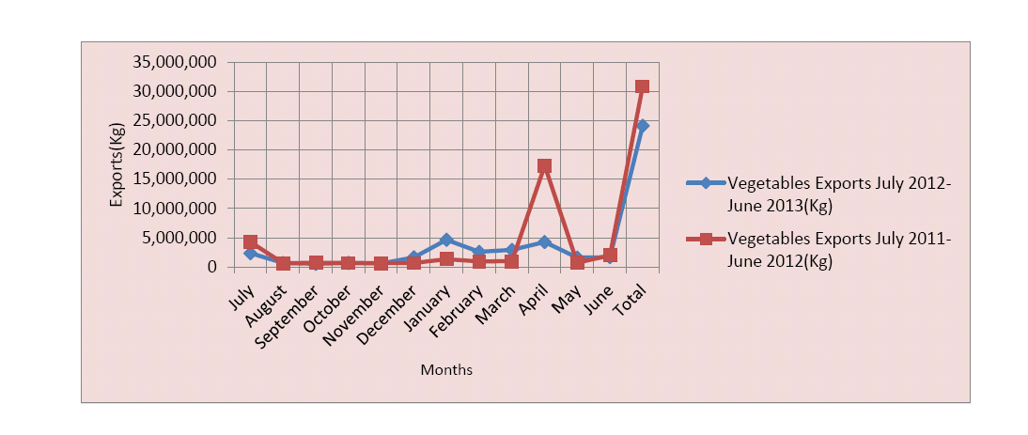

*Source: MINAGRI; Note: unknown reason for spike in 2011-12 export for the month of April; unknown vegetables included; unknown if inclusive of formal and informal export*

**Fresh vegetables for processing –** The vegetable processing sector has not been developed in Rwanda, but there is potential for collaborating with vegetable processors in the future. As mentioned previously, there was one known tomato processing plant, but reportedly it never fully functioned and has been completely out of operation for more than two years. There is some processing of hot peppers into chili sauce served at restaurant tables throughout the country. As EMIRGE opted to focus on higher volume crops, it was decided to not investigate this further at this point.

## 4.3 Value Chain Market Actors

During the analysis of the fresh vegetables value chain more than 30 interviews were conducted with market actors and key informants. (See Appendix 1 for a complete list of persons interviewed.)

The primary actors in the fresh vegetable value chain include the following:

* Input supply companies and retailers (seed, agricultural chemicals, fertilizers, and irrigation equipment)
* Producers (small and medium-large farmers)
* Traders (including cooperatives and exporters)
* Vegetable retailers (including supermarkets and open-air markets)
* Government Agencies (Ministry of Agriculture & Animal Resources (MINAGRI), National Agriculture Export Development Board (NAEB), Rwanda Agriculture Board (RAB), and Rwanda Cooperative Agency (RCA))

A value chain map showing the linkages between different market actors is shown below (Figure 2). Following the map, further information is given about each of the major market actors.

Figure 2: Fresh Vegetable Value Chain Map



### 4.3.1 Input Supply Companies and Retailers

Unlike other agriculture sectors, the vegetable sector has been primarily left to the private sector for inputs. While NAEB has provided some vegetable seed in the past, it has ceased doing so, allowing opportunities for private enterprises to thrive.

**Vegetable Seed –** All vegetable seed found in Rwanda was imported.Much of the seed is produced in South Africa, the Netherlands, or Kenya, by a sister or partner company. Seed import and distribution companies in Rwanda then work with the Rwanda Agriculture Board (RAB) to field test different varieties of vegetable seed and receive the proper documents to import and distribute. Several of the larger vegetable seed import and distribution companies are also major actors in the maize value chain, where they have been building distribution networks and brand recognition in Rwanda. At least one of the seed companies also supplies fertilizers and pesticides (i.e., Agrotech). Some of the seed companies are much newer to the market than others. For example, Agriseeds was started by an exporter who could not find the variety of vegetables in Rwanda that he wanted to export. So, he identified a seed company (Klein Karoo) to import and began distribution in late 2013. Another company, MySeeds, is importing seed in bulk and repackaging the seed under its own name (legality is questionable). A list of seed companies and their brands of seed are listed in Table 5.

Table 5: Known vegetable seed companies in Rwanda with brand of seed imported and distributed

|  |  |
| --- | --- |
| **Seed Company Name** | **Brand of Seed Imported and Distributed** |
| Agriseeds | Klein Karoo |
| Agrotech | Pop Vriend Seeds |
| East African Seed | East African Seed |
| Kenya Seed | Simlaw Seeds |
| MySeeds | MySeeds |
| Pannar Seed (partner with Murphy Chemicals) | Starke Ayres |
| Win-Win | n/a |

**Other inputs –** Other inputs include fertilizers, pesticides and irrigation equipment. Given the government’s role in fertilizer subsidies and distribution, farmers receive government-subsidized inputs only for specific crops (maize, wheat, potatoes, etc.). This means vegetable farmers must access fertilizers through alternative means, which are not as readily available on the marketplace. As a result, access and application of fertilizers by vegetable farmers has been limited. However, the fertilizer products do exist and distribution follows that of seed.

**Retailers –** Distribution of seed and other inputs takes place throughout the country through agro-dealers and agro-shops. There are currently 416 registered agro-dealers in the country. These agro-dealers are registered to distribute seed, fertilizer and other government-subsidized items for other crops. Many, but not all, of these agro-dealers also sell vegetable seed and other input supplies. In addition to agro-dealers, there are an estimated 300+ agro-shops throughout the country. These are typically smaller in size, carrying a diversity of items for agricultural purposes. The Team found that many of these shops provide products and services related to animal husbandry.

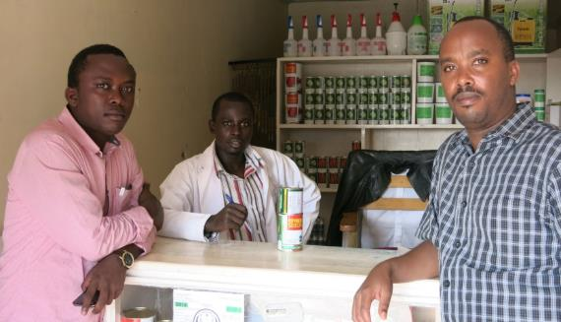One seed company, Agrotech, started its own network of franchises three years ago – there are 11 franchises as of the time of this study. These franchises are required to carry seed supplied by Agrotech, but have the ability to apply to headquarters for permission to also carry a competitor’s product should Agrotech not carry a particular vegetable variety. These Agrotech franchise operators tend to be more formally trained and have growing reputations in their communities. The Agrotech products cost more than competitors, but advertise better germination rates. Discounts are available at the franchise level, wholesaler and retailer level to create incentives in the distribution system. (Figure 3 shows a picture of the EMIRGE team with an Agrotech franchise operator in Rubavu.)

Figure 3: EMIRGE team with Agrotech franchise, Rubavu 2014

### 4.3.2 Producers

Producers in Rwanda are generally categorized into smallholder farmers with less than half a hector of land and medium-large farmers with more than 0.5 hectares. Producers may own their land, but it is also common to lease land from another landowner (neighbor or absentee) or, more commonly, from the Rwandan Government. In instances where the government owns the land, the authorities may mandate the crop (e.g., maize, potatoes, rice, etc.) that must be grown during a specific season, particularly in government-owned marshland areas. This diversity of land ownership results in a variety of challenges including government compliance, lease payments, and fragmented cultivation across the landscape, where producers are usually not farming contiguous areas. Farmers are primarily constrained by the limited access to land. While there may be opportunities to apply to the government for more land allocations, these lands are often already in use by another farmer or farmer cooperative.

The choice of vegetable cultivated varies primarily by region of the country, with some soils and markets being more appropriate than others for specific vegetables. Cultivation takes place primarily during seasons A and B, with growing interested in season C (the dry season). In marshland/ lowland areas which have not already been designated for conservation or rice cultivation, farmers may choose to cultivate vegetables. For areas without year-round rainfall, a pedal pump[4] or, better, a mechanized water pump[5] is necessary in order to cultivate during the dry season (C).

Farmers primarily sell their fresh produce in the local markets. As quantities are relatively low, competition is minor, and farmers are able to sell or consume most everything they produce. Others are organized into cooperatives, which bulk produce and market larger quantities. Cooperative membership is common, as producers have been encouraged by the Rwandan Government and NGOs to group into cooperatives to increase the effectiveness of their farms and to organize the distribution of training and resources to farmers. At present there are 11,900 registered members of 207 registered cooperatives involved in vegetable agriculture throughout the country. In some cases, cooperative members team together for various stages of production – from soil prep and purchase of input supply to cultivation, harvest, and marketing. Following harvest, the cooperative members pool their produce to sell it wholesale. Depending on the cooperative, some produce is retained for home consumption, while the remainder is taken to the market for sale. (Figure 4 shows a picture of the EMIRGE team with a group of farmers organized into Coculeka cooperative, in the Southern Province.)

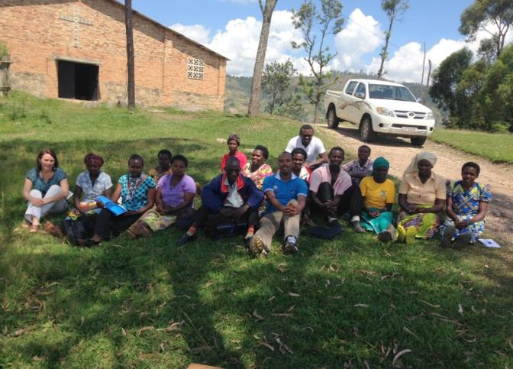Farmers typically have received little to no technical support. While a few may have participated in a government-led farmer field school, the opportunity has not been available to most and transfer of knowledge by those who have participated has also been limited. Some have received assistance ranging from a one-time training (from the Rwanda Cooperative Agency (RCA)) to long-term technical support regarding cooperative management by NGOs and/or NAEB. Given the relative youth of the vegetable sector in Rwanda, there is a broad lack of skills in vegetable cultivation, limiting yields for vegetable producers. Additional constraints are discussed in section 4.4.

### 4.3.3 Traders/ Wholesalers, Including Cooperatives and Exporters

With smallholder farmers holding very small amounts of land, bulking harvested vegetables is an important function in Rwanda’s fresh vegetable value chain. The primary actors responsible for bulking are cooperatives and traders/wholesalers.

Figure 4: EMIRGE team with farmers, members of COCULEKA cooperative

**Cooperatives –** As mentioned previously, there are currently 207 registered cooperatives[6] involved in vegetable agriculture throughout the country. Correspondingly, there are 11,900 registered vegetable farmers as members of these cooperatives. Cooperatives often manage the sales of bulk produce on behalf of the members. Additionally, cooperatives often assist members in bulk purchase and distribution of input supplies such as seed, irrigation equipment, fertilizer, etc. Some cooperatives have added side benefits to individuals, which may also benefit from the bulk purchasing of seed if integrated into the cooperative purchase order. Table 6 provides information about the cooperatives AFE and EMIRGE met with during the fresh vegetable value chain program design process.

Table 6: Cooperative information from fresh vegetable sector value chain program design

|  |  |  |  |  |  |  |  |
| --- | --- | --- | --- | --- | --- | --- | --- |
| **Cooperative interviewed** | **Currently**  **Works with EMIRGE** | **Location** | **Number of members** | **Hectares (ha)** | **Vegetables cultivated** | **Year begun cultivating vegetables** | **Sales** |
| COCULEKA | Yes | Southern province | 40 members (29 women) | 1 hectare, non-contiguous/ rented | Carrots (at first but no longer), white eggplant, tomatoes, onions | 2013 | 50% home; 50% sales |
| ABAJYANANIGIHE | No | Northern province, near Musanze | 32 members (14 women) | 3 – 4 ha, non-contiguous; additional 5 ha individually cultivated | Cabbage, carrots, white eggplant, tomatoes (also fruit trees) | 2008 | 100% (if enlisted in cooperative) |
| KAHIDU | No | Northern province, Rubavu District | 98 members (48 female; under 35 years old = 15) | 150 ha (owned by the individual members); another 100 ha individually cultivated | Onions, cabbage, carrots, dodo (in rotation with maize or Irish potatoes) | 2010 | 100% (if enlisted in cooperative) |
| MIHIGO | Yes | Northern province, between Musanze and Kigali | 26 members, 23 women | 2.4 ha, may be some individual lands | White eggplant, cabbage, and carrots (in rotation with maize) | 2014 | 100% (if enlisted in cooperative) |

EMIRGE currently works with 15 cooperatives (see Table 7 below), three of which have members growing vegetables and another eight that are engaged in other agricultural activities. Primarily EMIRGE provides support in organizing and operating cooperatives, which includes production as well as marketing of produce. GC provides the membership of these cooperatives with an agronomist consultant who advises the members regarding seed procurement, cultivation and harvest.

**Traders/wholesalers –** Equippedwith trucks (owned or rented), traders buy vegetables directly from farmers or cooperatives and sell on to more distant markets such as Kigali or internationally. It was challenging to find and interview traders/wholesalers, but it was clear that they play a vital role in the sector. Traders often bring the wholesaled goods to a central market, in Kigali for example, and sell again in bulk quantities (though typically small bulk sizes) to local retailers. In some instances, there is a regular buying relationship between farmers/ cooperatives and traders/ wholesalers, but this seemed to go on with no formal contracts (nor any interest in formalizing these working relationships).

Table 7: Information about cooperatives working with EMIRGE, 2014

|  |  |  |  |  |  |  |
| --- | --- | --- | --- | --- | --- | --- |
| ***No*** | ***Cooperative name*** | ***Activities*** | ***District*** | ***Membership*** | | |
|  |  |  |  | **Male** | **Female** | **Total** |
| **1** | COINYA | Soap making (and coffee growing) | Nyaruguru | 17 | 45 | 62 |
| **2** | COPMERU | Maize growing | Nyagatare | 8 | 23 | 31 |
| **3** | COTECYA | Handcraft (and coffee growing) | Nyaruguru | 66 | 173 | 239 |
| **4** | IGANABIKORWA | Handcraft | Kamonyi | 4 | 46 | 50 |
| **5** | IMPAKOMU | Seeds (maize) multiplication | Ruhango | 170 | 231 | 401 |
| **6** | KOARU | Maize and Beans | Ruhango | 145 | 136 | 281 |
| **7** | TUVUGE IBYAYO | Handcraft | Rubavu | 14 | 30 | 44 |
| **8** | TUZA BWISIGE | Services (sells maize, beans and sorghum) | Gicumbi | 18 | 44 | 62 |
| **9** | COPROMARU | Maize | Nyagatare | 11 | 22 | 33 |
| **10** | COCLRU | **Vegetables** | Nyagatare | 14 | 26 | 40 |
| **11** | INDATWA | Beans and Irish potatoes | Gicumbi | 19 | 7 | 26 |
| **12** | DUFATANYEGUKORA | Maize | Gakenke | 12 | 18 | 30 |
| **13** | MIHIGO | Maize, Irish potatoes and **Vegetables** | Rulindo | 3 | 20 | 23 |
| **14** | ISHINGIRO | Beans | Nyarugenge | 8 | 32 | 40 |
| **15** | COCULEKA | **Vegetables** | Ruhango | 14 | 26 | 40 |
|  | **Total** |  | | **523** | **879** | **1402** |

**Exporter traders –** For bulk sales to neighboring Democratic Republic of Congo, Uganda, and Burundi, where most exporting is taking place, traders play a most important role in delivering goods to market in a timely manner. As the export by air market begins to grow, export traders will also play a critical role.

KK Foods, a Ugandan company, recently opened a Rwandan entity to contract grow and export chilies to various international markets. In Uganda alone, this company sources from over 150,000 farmers, extending into 68 of 113 districts of Uganda. As Uganda’s supply of chilies does not meet demand (currently exporting 1.5 MT to Europe), KK Foods is expanding to Rwanda. At present they are working with farmers on 200 acres in 2014 for cultivation of a specific variety. This company’s export operations are one of few that the program design team was able to study, as export of Rwandan vegetables continues to be a less consistent and underdeveloped avenue for the vegetable sector at present.

### 4.3.4 Vegetable Retailers

A diversity of vegetables can be found in most any local open-air market or supermarket. Shortages fall during the dry season when fewer vegetables are grown and harvested. Prices fluctuate with the timing of supply within the marketplace.

While some farmers will try to retail themselves, typically retail is done by a person dedicated to vegetable sales full-time. Retailers often purchase from traders at the local wholesale/ bulk market and retail at a local marketplace. Alternatively, some Kigali-based retailers travel outside of Kigali themselves to play the role of the trader and buy vegetables a few times a week to resell in the local market. (Figure 5 shows the EMIRGE team interviewing retailers in Rubavu.)

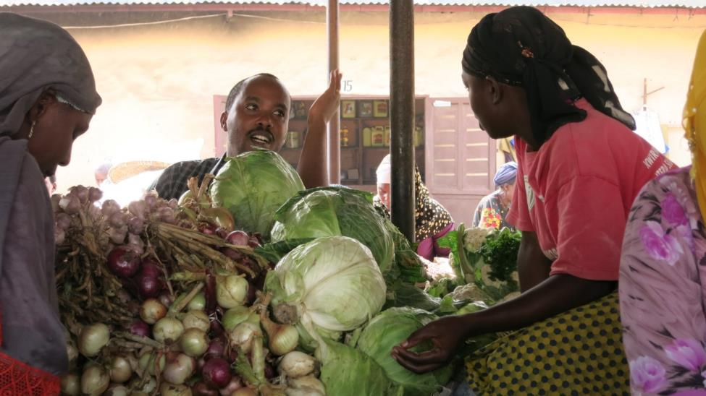There are a few supermarkets in Kigali which retail vegetables. They do not have contracts with suppliers and will accept most any good produce brought directly to them. One supermarket does have at least one consistent large-scale farmer which has brought consistent large quantities for more than a decade.

Figure 5: EMIRGE team with vegetable retailers, Rubavu, 2014

### 4.3.5 Government Agencies

The Government of Rwanda, through agencies of the Ministry of Agriculture (MINAGRI) and the Rwanda Cooperative Agency (RCA), plays a supportive role in promoting the production of vegetables. Government policies and activities of these entities have helped shape the vegetable sector. Each government agency which plays a role in the fresh vegetable value chain is described below.

**National Agriculture Export Development Board (NAEB)** – Part of MINAGRI, NAEB provides all services previously provided by the Rwanda Coffee Development Authority (OCIR CAFE), Rwanda Tea Development Authority (OCIR THE) and Rwanda Horticulture Development Authority (RHODA). Its responsibilities include:

* elaboration and implementation of policies and strategies for developing exports of agricultural and livestock products;
* identification and support of research, training and agricultural extension regarding agricultural and livestock products for export;
* collaboration with other institutions to identify places where to install factories processing agricultural and livestock products;
* establishment of quality standards and issuing of certificates of origin for agricultural and livestock products for export as provided for by relevant laws;
* collection and dissemination of information on local, regional and international markets to industry stakeholders and to increase investments in industry and infrastructure;
* participation in various international negotiations and trade fairs; and
* establishment of good relations with international organizations.

Various divisions of NAEB provide technical support to farmers and help connect traders/ exporters with supply. NAEB conducts its own research, but typically does not publish or share this data externally.

**Rwanda Agricultural Board (RAB)** – This MINAGRI division is responsible for coordinating research and variety approval for the vegetable sector. More broadly, RAB is responsible for agricultural industry coordination. During the value chain program design, RAB hosted the AGRISHOW – a weeklong fair with demonstration plots and equipment as well as booths highlighting products and services of various market actors in the broader agriculture sector. This is well attended by the local agriculturalists and industry actors, but is not well attended by those outside of the greater Kigali area. (See maize value chain report for description of RAB involvement in distribution of government-subsidized fertilizer.)

One office within RAB which plays another important role for vegetable farmers is the Extension Services Department. This office, as the name suggests, is responsible for providing training and extension services to farmers in Rwanda. This office manages an extensive system of extension agents and “farmer promoters” who provide differing levels of training and informational materials to farmers.

**Rwanda Cooperative Agency (RCA) –** This agency oversees formal cooperatives throughout the country and provides technical support regarding cooperative management. Formal cooperatives must register with this agency to be formally recognized by the Government of Rwanda.

## 4.4 Constraints and Market-based Solutions

The agriculture sector in Rwanda faces a unique set of challenges. Because of the high population density, land is a scarce commodity, yet labor is abundant. Given the hilly terrain throughout the country, slopes range up to 55% grade. As a result, the land is at high risk of erosion, and soil fertility continues to deteriorate dramatically over time, intensifying the need for improved cultivation techniques, fertilizer applications, and crop rotations.

During the analysis of the fresh vegetable value chain a number of constraints were cited by the market actors interviewed. Table 8 below presents these constraints, along with associated market-based solutions that could potentially address them. The market-based solutions in bold represent those that were prioritized for further assessment (the prioritization process used is described in more detail below). The fourth column (ranking) is described in the following section 4.5.

Table 8: Fresh Vegetable Value Chain Constraints and Market-based Solutions

| **TYPE** | **Value Chain Constraints** | **Market-based Solutions (MBSs)** | **Rankings[7]** |
| --- | --- | --- | --- |
| **Technological / Product Development** | * Vegetable farmers lack the capacity/ skills to implement modern cultivation techniques which limits their abilities to increase their yields, quality of the produce, and ultimately income. | 1. **Provision of information/ training on modern cultivation techniques to increase yields for vegetable farmers** | **H/H** |
| * Vegetable farmers lack knowledge in mitigating vegetable crop disease which results in improper application of pesticides and lower yields. | 1. **Provision of information/ training to vegetable farmers regarding how to mitigate vegetable crop disease** | **M/H** |
| * Many vegetable farmers are not aware of proper post-harvest handling techniques which reduces the quality of their harvest and decreases their potential income. | 1. Provision of information on proper/ suitable post-harvest handling techniques for vegetable farmers | M/M |
| * Vegetable farmers (with access to marshlands for cultivation) lack water pumps and pedal pumps to cultivate in marshlands in the dry season (between seasons B and A) resulting in little to no production during this period of time, inability to meet market demand, and thus no revenue generation. | 1. **Access to water pumps for vegetable farmers who will cultivate marshlands during the dry season.** | **H/M** |
| * Lack of greenhouses for vegetable farmers limits production of vegetables and subjects farmers to seasonal weather fluctuations. | 1. Access to greenhouses for vegetable farmers to increase yields. | M/L |
| **Market Access** | * Vegetable farmers lack information about external market standards and the capacity/ skills to meet these standards which limits their potential for export. | 1. Provision of training / information to vegetable farmers in modern cultivation and post-harvest handling techniques, to meet market standards for export and other high-end markets. | M/M |
| * Vegetable farmers lack access to fixed/steady/reliable buyers resulting in significant resources utilized to find market outlets after each production cycle. | 1. Access to additional (ideally fixed/steady/reliable) buyers for vegetable farmers. | M/M |
| * Vegetable farmers are unable to supply the export market (excluding DRC) for onions because of requirements for onions to be dried prior to export, which limits market opportunities. | 1. Access for vegetable farmers to export markets for onions. | M/M |
| * Vegetable farmers are unable to meet the demand of exporters, supermarkets, and other high-end markets due to poor transportation and packaging materials used in getting produce to distant markets (such as Kigali), limiting their market potential. | 1. Access for vegetable farmers to high-end markets such as to supermarket and export markets. | M/M |
| **Organization and Management** | * Vegetable farmers lack skills to develop production plans which require an evaluation of market demands, understanding of market standards, crop selection, and cultivation plans, thereby limiting their abilities to meet market demands (such as demand of exporters). | 1. Provision of information about production planning according to market demands and standards for vegetable farmers to ensure better crop selection, timely cultivation and harvesting, and optimization of income. | M/M |
| **Regulatory (Policy)** | * Many vegetable farmers with government controlled marshlands are mandated by the Rwandan government to cultivate maize and other priority crops (primarily during season A) which limits the number of production cycles for vegetables farmers and their profitability. | See MBSs A and D. | n/a |
| **Finance** | * Vegetable farmers lack access to finance for capital investments / investments in equipment for dry season cultivation. | 1. Access to finance for small-holder vegetable farmers. | M/M |
| **Input Supply** | * Packet sizes (of well-sealed) vegetable seeds are not small enough for some small-holder vegetable farmers to afford, which results in agro-dealers/shops breaking up the packets themselves without proper sealing or storage. In the end this hurts the brand image of the seed importers and vegetable producers question the quality of seeds they are receiving. | 1. Access to smaller sizes of vegetable seed packets which are well sealed for vegetable farmers. | M/M |
| * Vegetable farmers lack knowledge about quality seed brands and varieties (e.g., hybrid cabbage seed), which limits their production capabilities. | 1. **Provision of information about quality vegetable seed brands and varieties for vegetable farmers.** | **M/H** |
| * Vegetable farmers lack access to different quality seed brands and varieties (e.g., hybrid cabbage seed), particularly during periods of high demand, which limits their production capacity and income. | 1. **Access to additional varieties of quality vegetable seed for vegetable farmers.** | **M/M** |
| **Infrastructure** | * Vegetable farmers have limited access to land for cultivation which limits production and total yield. | Same as C, with specific focus on existing plots: Provision of information on modern cultivation techniques for vegetable farmers to increase yield at existing plots. | n/a |

## 4.5 Prioritization of Market-based Solutions

Once the final list of constraints and market-based solutions (MBSs) was identified, the team prioritized each of the MBSs on the basis of: i) their potential to increase the growth and competitiveness of the fresh vegetable value chain, and ii) their potential to benefit the greatest number of farmers (MSMEs).  The grid below (Figure 6) shows how each of the market-based solutions from the table above was prioritized and ranked.

Figure 6: Market-based Solutions Ranking Grid – Fresh Vegetable Value Chain

High

Medium

High

Low

Low

Medium

***B, M***

**Number of MSMEs in Target Group that will benefit (directly & indirectly)**

C, F, G, H, I, J, K, L, ***N***

E

***A***

***D***

**Potential to Increase Value Chain Growth and Competiveness**

The following MBSs were selected as having the highest potential to meet the above-mentioned criteria:

1. Provision of **information/ training on modern cultivation techniques** to increase yields for vegetable farmers
2. Provision of **training /information** to vegetable farmers regarding **how to mitigate vegetable crop disease**
3. Provision of **information about quality vegetable seed** **brands and varieties** for vegetable farmers
4. **Access to additional quality vegetable seed** brands and varieties for vegetable farmers
5. **Access to irrigation equipment** for vegetable farmers to facilitate cultivation during the dry season

It is important to note that as the program develops, some of these MBSs (and corresponding constraints) may be revisited based on better understanding, new opportunities for program facilitation activities, or if realities on the ground in the value chain change. The promotion of additional MBSs would also be beneficial but might not be possible given program limitations.

# 5. Assessment of Market-based Solutions & Identification of Program Facilitation Activities

Having completed the aforementioned activities, the team carried out assessments of the prioritized market-based solutions (MBSs). These assessments included identification of Lead Firms (LFs), companies with commercial incentives to provide the targeted MBS to producers. For the fresh vegetable sector these included vegetable seed companies, agricultural chemical companies, traders, agro-dealers/shops, and irrigation equipment suppliers among others. Considered were the LFs challenges and incentives for providing each MBS as well as their potential cost-recovery mechanisms. Additionally, the MBSs were assessed from the producers’ perspectives as to their challenges and incentives for accessing the MBSs. Based on these analyses, the LFs most likely to provide each MBS were selected as the primary targeted providers.

AFE and EMIRGE gathered feedback from some of the targeted LFs to better understand the incentives and challenges they face in providing the MBSs in a sustainable manner. The Team hoped to host a focus group discussion (FGD) during the AFE consultant’s visit with a group of LFs. However, the AGRISHOW (an agriculture trade show hosted by MINAGRI/ RAB) was taking place June 6th to 12th, and most of the targeted LFs were busy with preparation, the show, and post-show activities. Alternatively, AFE and the EMIRGE team attended the show and spoke one-on-one with a few key LFs.

While the Team received valuable feedback and confirmed interest in collaboration from LFs with whom the Team spoke, the EMIRGE team will need to follow up with additional LFs through one-on-one interviews, invitations for applications (IFAs), and/or an FGD. (See Section 6, *Recommendations and Next Steps,* for more information.)

These assessments will enable the EMERGE team to further identify initiatives that LFs want to carry out – that will increase their competitiveness and improve, develop or expand the products, services or support they provide to the MSMEs with whom they transact. These initiatives are typically interventions that the LF would not otherwise undertake in the near term due to risk, cost, and lack of technical support, but with assistance from EMIRGE could be catalyzed to commence. LF initiatives can include a variety of activities such as staff capacity building, development of outgrowing operations, pilot training for producers, new product development, exposure visits and exploration of new markets.

Some potential LF initiatives were suggested by LFs themselves at the AGRISHOW. These are noted in the tables that follow and include potential EMIRGE program facilitation activities that could build the capacity of LFs to implement their proposed initiatives. The following tables 9 – 13 describe the assessments for each MBS including challenges and incentives of proposed LFs, challenges and incentives of producers, illustrative LF initiatives, and illustrative EMIRGE facilitation activities.

Table 9: Market-based Solution #1 - *Provision of information/ training on modern cultivation techniques to increase yields for vegetable farmers*

|  |
| --- |
| MARKET-BASED SOLUTION (MBS) #1: |
| Provision of **information and/or trainings in modern cultivation techniques** (possibly including use of chemical applications (see MBS #2)) to increase yields for vegetable farmers. Information may take the form of trainings, exposure visits, demonstration plot site visits, posters, brochures, leaflets, etc. as determined with providers of the market-based solution. |
| VALUE CHAIN CONSTRAINT |
| Vegetable farmers lack the capacity/ skills to implement modern cultivation techniques which limits their abilities to increase their yields, quality of the produce, and ultimately income. |
| EXISTING OR POTENTIAL MBS PROVIDERS |
| * Seed supply companies * Pesticide companies * Traders * Agro-dealers/shops * Vegetable marketing cooperatives * Agro-consultants * Universities/ training facilities * TV companies |
| CHALLENGES AND INCENTIVES TO PROVIDING THE MBS |
| Aside from some trained agro-dealers/shops and a handful of technical advisors working for some of the seed companies, few of these providers currently have the capacity to provide trainings/ information to farmers. Government extension has been providing some advice and trainings to farmers, such as a Farmer Field School, but this represents an insignificant number of farmers. As vegetable cultivation and private-sector distribution of seed is a relatively young sector in Rwanda (within last 10 years), knowledge about effective cultivation remains elementary. |
| *Challenges and Incentives for MBS providers:* |
| * To develop, print, and/or distribute training and other information materials, these providers lack the necessary staff, expertise, and funding. * **Seed and pesticide companies** – most have weak distribution systems and thus would be challenged to extend services to farmers. Also lack direct contact with vegetable farmers. Collaboration with agro-dealers/shops and/or franchises would be necessary. *Their incentive is to promote their products, brand image, increase sales and develop market share.* * **Traders** – lack incentives to invest in their supply chains. They typically have inconsistent relationships with vegetable farmers and prefer impermanent ties. Additionally, they lack farming skills themselves. *Their incentive is to get improved quality and quantity of produce that corresponds with market demand.* * **Agro-dealers/shops** – lack the resources, primarily skills and number of staff, to effectively provide support to farmers. *Their incentive is to increase sales, develop reputations for quality services, and develop local market share.* * **Vegetable marketing cooperatives** – lack the skills and capacities themselves and often are struggling to sustainably manage themselves. *Their incentive is to get improved quality and quantity of produce that corresponds with market demand.* * **Television programming, agro-consultants, universities and other training facilities** – would require payment for services rendered or sponsorships from the private sector. Also, few households have access to televisions. *They would have an incentive if paid by seed companies or other market actors.* |
| CHALLENGES AND INCENTIVES FOR FARMERS TO USE THE MBS |
| *Challenges for Small-holder Vegetable Farmers:* |
| * Some farmers are reluctant to try new techniques or grow new crops/ varieties, so a change in mindset may be necessary. * Farmers have limited funds to pay for training or information which is not already embedded in the purchase of a product or service. * Farmers may be challenged by the distances required to travel for training/information. * In the case of written information, there may be a language or literacy barrier for some farmers. |
| *Incentives for Small-holder Vegetable Farmers:* |
| * Many farmers have not received training in the past related to vegetable cultivation, but rather have been learning through trial and error. They are eager to receive additional information to increase their yields and improve the quality of their produce. |
| PROPOSED PROVIDER OF THE MBS |
| Seed companies as the primary provider, with distribution of information/ trainings conducted in collaboration with agro-dealers/shops and Agrotech franchises. Pesticide companies can also be a resource for cultivation techniques related to chemical applications.  Rationale: Seed companies expressed the greatest interest in propelling their brand image and seed sales throughout the country. They recognize that farmers, if not cultivating effectively, may place blame on the seed supply for low yields and productivity. In providing training and information related to effective vegetable cultivation, seed companies will improve the reputation of their seeds, while building a brand image of working for the farmers. |
| ILLUSTRATIVE LEAD FIRM INITIATIVES |
| Illustrative initiatives proposed by seed companies are primarily related to expanding their existing outreach. Seed companies which were interviewed expressed interest in carrying out the following initiatives:   * provide information about cultivation of vegetables through additional live radio broadcasts, which allow for farmers to call with pressing questions; * increase distribution of disease photo booklets (such as those prepared by Rwanda Agricultural Board) * promote Farmer Days at demonstration plots and research stations where vegetable trials are undertaken in partnership with the polytechnic universities * provide information in the form of leaflets which address specific problem areas vegetable farmers face for each specific crop * promote RAB’s plant clinics to extend outreach to vegetable farmers * educate agro-dealers/shops who in turn provide technical support to vegetable farmers   These activities were proposed by only a few seed companies and are only illustrative. Moving forward, a broader, more comprehensive process of soliciting company initiatives should take place through an Invitation for Applications process, a focus group discussion and/or follow-up interviews with additional seed companies. |
| ILLUSTRATIVE EMIRGE FACILITATION ACTIVITIES TO SUPPORT LF INITIATIVES |
| Illustrative EMIRGE facilitation activities to support LFs to implement their initiatives include the following:   1. Support in planning and organizing initiatives  * Help the company(s) design a potential suite of activities, or alternatively help them focus their activities, within their initiative * Example: Support company to design public outreach/ information distribution plan for radio broadcasts—help identify stations, evaluate broadcast range, consider timing, select topics for discussion, and provide experts for technical advice * Help the company determine an intervention’s feasibility (including the projected costs) by helping them to carefully review and plan for their initiatives, including a review and rationalization of all costs involved * Help develop a work plan for implementation  1. Provide technical support to carry out initiatives  * Support company in identifying technical skills needed by vegetable farmers to successfully use their products * Support company in the design of informational/training materials to relay information in an effective manner * Support companies in piloting distribution of information, getting feedback, and making adjustments before further outreach  1. Build LF staff training capacity  * Assist the company to prepare training materials for producer or agro-dealer/shop training activities * Assist the companies to assemble training/ coaching teams of company staff and expert farmers * Facilitate the organization of training of trainers (TOT) for company training/coaching teams in which they review and then practice delivering the training modules. (Note, TOTs can include both technical elements and participatory adult learning methodologies.) * Monitor the company training/ coaching team’s activities during the first few training session and provide detailed feedback. |

Table 10: Market-based Solution #2 - *Provision of training /information to vegetable farmers regarding how to mitigate vegetable crop disease*

|  |
| --- |
| MARKET-BASED SOLUTION (MBS) #2: |
| Provision of **information and/or trainings** to vegetable farmers regarding **how to mitigate vegetable crop** disease (possibly in conjunction with MBS #1 – provision of information/ trainings in modern cultivation techniques) to increase yields for vegetable farmers. |
| VALUE CHAIN CONSTRAINT |
| Vegetable farmers lack knowledge in mitigating vegetable crop disease which results in improper application of pesticides and lower yields. |
| EXISTING OR POTENTIAL MBS PROVIDERS |
| * Seed supply companies * Pesticide companies * Traders * Agro-dealers/shops * Vegetable marketing cooperatives * Agro-consultants * Universities/ training facilities * Television programming |
| CHALLENGES AND INCENTIVES TO PROVIDING THE MBS |
| Aside from some trained agro-dealers/shops and a handful of technical advisors working for some of the pesticide companies, few of these providers currently have the capacity to provide trainings/ information to farmers. Rwanda Agriculture Board (RAB) has prepared some photo booklets about disease mitigation in the past. As vegetable cultivation is a relatively young sector in Rwanda (within last 10 years), knowledge about a diversity of vegetable crop diseases and corresponding mitigation tactics remains elementary. |
| *Challenges and Incentives for MBS providers:* |
| * To develop, print, and/or distribute training and other information materials, these providers lack the necessary staff, expertise, and funding. * **Pesticide and seed companies** –many have weak distribution systems and thus would be challenged to extend services to farmers. They also lack direct contact with vegetable farmers, making collaboration with agro-dealers/shops and/or franchises necessary. *Their incentive is to promote their products, brand image, increase sales and develop market share.* * **Traders** – lack incentives to invest in their supply chains. They typically have inconsistent relationships with vegetable suppliers and prefer impermanent ties. Additionally, they lack disease mitigation skills themselves. *Their incentive is to get improved quality and quantity of produce that corresponds with market demand.* * **Agro-dealers/shops** – lack the resources, primarily skills and number of staff, to effectively provide support to farmers. *Their incentive is to increase sales, develop reputations for quality services, and develop local market share.* * **Television programming, agro-consultants, universities and other training facilities** – would require payment for services rendered or sponsorships from private companies. Also, few households have access to televisions. *They would have an incentive if paid by pesticide companies or other market actors.* |
| CHALLENGES AND INCENTIVES FOR FARMERS TO USE THE MBS |
| *Challenges for Small-holder Vegetable Farmers:* |
| * Many farmers are price sensitive and prefer to wait to see if their crops are first impacted by disease, thus not undertaking proactive measures to avoid crop disease. * Some farmers are reluctant to try new techniques or new brands of pesticide, so a change in mindset may be necessary. * Farmers have limited funds to pay for training or information which is not already embedded in the purchase of a product or service. * Farmers may be challenged by the distances required to travel for training/information. * In the case of written information, there may be a language or literacy barriers for some farmers. |
| *Incentives for Small-holder Vegetable Farmers:* |
| * Many farmers have not received training in the past related to mitigating crop disease, specifically for different varieties of vegetables, but rather have been learning through trial and error. They are eager to receive additional information to increase their yields and improve the quality of their produce. |
| PROPOSED PROVIDER OF THE MBS |
| Seed companies as the primary providers, with distribution of information/ trainings conducted in collaboration with agro-dealers/shops and franchises. Pesticide companies can also be a strong partner.  Rationale: Seed companies expressed the greatest interest in propelling their brand image and seed sales throughout the country. They recognize that farmers, if not cultivating effectively, may place blame on the seed supply for low yields and productivity. In providing training and information in vegetable crop disease mitigation, seed companies will improve the reputation of their seeds, while building a brand image of working for the farmers. |
| ILLUSTRATIVE LEAD FIRM INITIATIVES |
| Illustrative initiatives proposed by seed companies are primarily related to expanding their existing outreach (beyond their primary focus on maize). Seed companies which were interviewed expressed interest in carrying out the following initiatives:   * provide information about disease mitigation for vegetables through live radio broadcasts, dissemination of RAB photo booklets, demonstrations at research stations and farmer plots, leaflets, and additional plant clinics.   These activities were proposed by only one seed company. Other seed companies may have additional ideas, which can be explored through an Invitation for Applications process, a focus group discussion and/or follow-up interviews with additional seed or pesticide companies. |
| ILLUSTRATIVE EMIRGE FACILITATION ACTIVITIES TO SUPPORT LF INITIATIVES |
| Illustrative EMIRGE facilitation activities to support LFs to implement their initiatives include the following:   1. Support in planning and organizing initiatives  * Help the company(s) design a potential suite of activities, or alternatively help them focus their activities, within their initiative * Example: Support company to prepare photo booklets about vegetable crop disease: identify problem crops and diseases, collect corresponding photographs, provide experts to assist in outlining mitigation tactics, and prepare distribution plan * Help the company determine an intervention’s feasibility (including the projected costs) by helping them to carefully review and plan for their initiatives, including a review and rationalization of all costs involved * Help develop a work plan for implementation  1. Build LF staff training capacity  * Assist the company to prepare training materials for producer or agro-dealer/shop training activities * Assist the companies to assemble training/ coaching teams of company staff and expert farmers * Facilitate the organization of training of trainers (TOT) for company training/coaching teams in which they review and then practice delivering the training modules. (Note, TOTs can include both technical elements and participatory adult learning methodologies.) * Monitor the company training/ coaching team’s activities during the first few training session and provide detailed feedback. |

Table 11: Market-based Solution #3 - *Provision of information about quality vegetable seed brands and varieties for vegetable farmers*

|  |
| --- |
| MARKET-BASED SOLUTION (MBS) #3: |
| Provision of **information about quality vegetable seed brands and varieties** for vegetable farmers. Information may take the form of exposure visits, demonstration plot site visits, posters, brochures, leaflets, etc. as determined with providers of the market-based solution. |
| VALUE CHAIN CONSTRAINT |
| Vegetable farmers lack knowledge about quality seed brands and varieties (e.g., hybrid cabbage seed), which limits their production capabilities. |
| EXISTING OR POTENTIAL MBS PROVIDERS |
| * Seed supply companies * Agro-dealers/shops * Traders * TV companies |
| CHALLENGES AND INCENTIVES TO PROVIDING THE MBS |
| Aside from the seed companies themselves, agro-dealers/shops primarily provide information to vegetable farmers about seed brands and varieties. They, however, limit the information they share to the seed brands and varieties which they sell. As vegetable cultivation and private-sector distribution of seed is a relatively young sector in Rwanda (within last 10 years), knowledge about quality seed brands and varieties remains elementary. |
| *Challenges and Incentives for MBS providers:* |
| * To develop, print and distribute information about seed requires staff, expertise and funding that not many potential providers (like seed companies, agro-dealers/shops, or traders) have on hand. * **Seed companies** – most are new to Rwanda and are just beginning to build their distribution systems. As a result, their outreach to farmers has been limited to existing channels of distribution. Additionally, these companies lack brochures/ leaflets in general. For those that do have these promotional materials, the marketing materials are often looking outdated and are only available in English. Furthermore, seed companies, for the most part, lack direct contact with vegetable farmers. Collaboration with agro-dealers/shops and/or franchises would be vital. *Their incentive is to promote their products, brand image, increase sales and develop market share.* * **Agro-dealers/shops** – lack the resources, primarily skills and number of staff, to effectively provide support to farmers. *Their incentive is to increase sales, develop reputations for quality seed, and develop local market share.* * **Traders** – lack incentives to invest in their supply chains. They typically have inconsistent relationships with vegetable suppliers. Additionally, they lack an understanding or access to information about available, quality seed. *Their incentive is to get improved quality and quantity of produce that corresponds with market demand.* * **Television companies** – would require payment for services rendered or sponsorships from the private sector. Also, few households have access to televisions. *They would have an incentive if paid by seed companies or other market actors.* |
| CHALLENGES AND INCENTIVES FOR FARMERS TO USE THE MBS |
| *Challenges for Small-holder Vegetable Farmers:* |
| * Farmers have been reliant on their local agro-dealers/ shops or extension agents for information on quality seed brands and varieties. Aside from these local agro-dealers/shops, farmers are unaware of where they could find additional information about vegetable seed, which has limited their search for additional information. * Farmers remain skeptical about seed packages being tainted. * Even if aware of other seed brands or varieties, most farmers remain limited by the seeds available in their local areas. Otherwise the farmers must travel long distances to acquire quality seed. * Some farmers are reluctant to try new seed brands or varieties unless they can see or hear from other farmers about their performance, so a change in mindset or sampling may be necessary. * Farmers have limited funds to pay for information which is not already embedded in the purchase of a product or service. * Farmers may be challenged by the distances required to travel for seed information. * In the case of written information, there may be a language or literacy barrier for some farmers.[8] |
| *Incentives for Small-holder Vegetable Farmers:* |
| * Some farmers have heard rumor of hybrid seed varieties and are eager for additional information. * Most farmers have not received training in the past about seed brands and varieties. * Quality seed will help farmers increase yields, potentially decrease costs of other inputs and labor, and in turn, increase their incomes. |
| PROPOSED PROVIDER OF THE MBS |
| Seed companies as the primary provider, with distribution of information conducted in collaboration with agro-dealers/shops and Agrotech franchises.  Rationale: Seed companies expressed the greatest interest in propelling their brand image and seed sales throughout the country. They recognize that their distribution systems could be improved. In providing information related to quality seed and varieties, seed companies will improve the reputation of their seeds, while building a brand image of working for the farmers. |
| ILLUSTRATIVE LEAD FIRM INITIATIVES |
| Illustrative initiatives proposed by seed companies are primarily related to expanding their existing outreach. Seed companies which were interviewed expressed interest in carrying out the following initiatives:   * provide information about seed varieties through additional live radio broadcasts, which allow for farmers to call with pressing questions; * promote Farmer Days at demonstration plots and research stations where vegetable trials are undertaken in partnership with the polytechnic universities * provide information in the form of leaflets which highlight a diversity of vegetable varieties and their recommended cultivation practices * educate agro-dealers/shops who in turn provide seed information to vegetable farmers   These activities were proposed by a few seed companies and are therefore illustrative. Moving forward, a broader, more comprehensive process of soliciting company initiatives should take place through an Invitation for Applications process, a focus group discussion and/or follow-up interviews with additional seed companies. |
| ILLUSTRATIVE EMIRGE FACILITATION ACTIVITIES TO SUPPORT LF INITIATIVES |
| Illustrative EMIRGE facilitation activities to support LFs to implement their initiatives include the following:   1. Support in planning and organizing initiatives  * Help the company(s) design a potential suite of activities, or alternatively help them focus their activities, within their initiative * Example: Provide technical/financial support to company to establish demonstration plots for Farmer Demonstration Days at strategic locations throughout various districts – analyze potential districts for demonstration purposes, identify Master Farmers to collaborate for cultivation, training of Master Farmers (see #2 below), identify way to promote Farmer Demonstration Days, and get feedback from farmers at demonstration * Help the company determine an intervention’s feasibility (including the projected costs) by helping them to carefully review and plan for their initiatives, including a review and rationalization of all costs involved * Help develop a work plan for implementation  1. Build LF staff training capacity  * Assist the company to prepare training materials for training Master Farmers (farmers selected in strategic locations to host Farmer Demonstration Days) * Assist the companies to assemble training/ coaching teams of company staff and expert farmers * Facilitate the organization of training of trainers (TOT) for company training/coaching teams in which they review and then practice delivering the training modules. (Note, TOTs can include both technical elements and participatory adult learning methodologies.) * Monitor the company training/ coaching team’s activities during the first few training session and provide detailed feedback |

Table 12: Market-based Solution #4 - *Access to additional quality vegetable seed brands and varieties for vegetable farmers*

|  |
| --- |
| MARKET-BASED SOLUTION (MBS) #4: |
| **Access to additional varieties of quality vegetable seed** for vegetable farmers. |
| VALUE CHAIN CONSTRAINT |
| Vegetable farmers lack access to quality seed brands and varieties (e.g., hybrid cabbage seed), particularly during periods of high demand, which limits their production capacity and income. |
| EXISTING OR POTENTIAL MBS PROVIDERS |
| * Seed supply companies * Agro-dealers/shops * Traders |
| CHALLENGES AND INCENTIVES TO PROVIDING THE MBS |
| As vegetable cultivation and private-sector sale of seed is a relatively young sector in Rwanda (within last 10 years), distribution systems for seed companies are limited in scope, with some more prevalent in certain regions than others. While there are tremendous opportunities for market penetration ahead, the distribution networks for seed are relatively elementary. As a result, the seed available in rural areas for farmers is limited in terms of brands and varieties. |
| *Challenges and Incentives for MBS providers:* |
| * **Seed companies** – most are new to Rwanda and are just beginning to build their distribution networks. As a result, the availability of their seeds on the market has been limited to existing channels of distribution. Additionally, to develop new relationships with agro-dealers/shops takes time and other resources, particularly given the large number of agro-dealers/shops in Rwanda. Furthermore, seed companies must perform trials of new varieties to ensure they will produce well prior to sales on the market. *Their incentive is to promote their products, brand image, increase sales and develop market share.* * **Agro-dealers/shops** – are unaware of the new seed companies or the quality of their products. They also face challenges keeping a steady supply of seed, particularly during the sowing season. Often this is due to seed companies only importing on demand and not keeping a sufficient stock in Rwanda. *Their incentive is to increase sales, develop reputations for quality seed, and develop local market share.* * **Traders** –lack incentives to invest in their supply chains. They typically have inconsistent relationships with vegetable suppliers. Additionally, they lack an understanding about quality seed. *Their incentive is to get improved quality and quantity of produce that corresponds with market demand.* *Opportunity to build steady relationships between traders and farmers as well.* |
| CHALLENGES AND INCENTIVES FOR FARMERS TO USE THE MBS |
| *Challenges for Small-holder Vegetable Farmers:* |
| * Farmers have been reliant on their local agro-dealers/ shops or extension agents for seed and thus have been limited to the brands and varieties available locally. Otherwise the farmers must travel long distances to acquire quality seed. * Farmers remain skeptical about seed packages being tainted. * Some farmers are reluctant to try new seed brands or varieties unless they can see or hear from other farmers about their performance, so a change in mindset or sampling may be necessary. * Some farmers are also reluctant to try new varieties if the market demand for that crop is uncertain. * Farmers are price sensitive. |
| *Incentives for Small-holder Vegetable Farmers:* |
| * Some farmers have heard rumor of hybrid seed varieties and are eager to try them. * Quality seed will help farmers increase yields, improve the quality of their produce, potentially decrease costs of other inputs and labor, and in turn, increase their incomes. |
| PROPOSED PROVIDER OF THE MBS |
| Seed companies as the primary provider, with access to seed provided in collaboration with agro-dealers/shops and Agrotech franchises.  Rationale: Seed companies expressed the greatest interest in propelling their brand image and seed sales throughout the country. They recognize that their distribution systems could be improved. In providing improved access to quality seed and varieties, seed companies will improve the reputation of their seeds, while building a brand image of working for the farmers. |
| ILLUSTRATIVE LEAD FIRM INITIATIVES |
| As mentioned previously, sale of vegetable seed in Rwanda is less developed than with maize (which has received support through government subsidy and distribution systems). Several seed companies recognize there is a need to expand their distribution networks and would like support in doing so. For Agrotech, a seed company with a more developed distribution system, there is a need for more varieties of seed so their franchises do not need to supplement Agrotech seed with as many competitor brands and varieties.  EMIRGE will need to seek more specific information and ideas about initiatives which the seed companies would like support in undertaking. Ideas from seed companies can be sought through an Invitation for Applications process, a focus group discussion and/or follow-up interviews with additional seed companies. |
| ILLUSTRATIVE EMIRGE FACILITATION ACTIVITIES TO SUPPORT LF INITIATIVES |
| Illustrative EMIRGE facilitation activities to support LFs to implement their initiatives include the following:   1. Support in planning and organizing initiatives  * Help the company design a potential suite of activities, or alternatively help them focus their activities, within their initiative * Help the company determine an intervention’s feasibility (including the projected costs) by helping them to carefully review and plan for their initiatives, including a review and rationalization of all costs involved * Help develop a work plan for implementation  1. Support LFs to develop and expand distribution networks to rural producers  * Organize LF exposure visit to witness first-hand successful seed distribution networks in other countries * Support LFs in designing seed displays to increase appeal in retail shops * Support LFs in informing/ training agro-dealers/shops about wholesales pricing, seed quality, and ordering process for new seed brands and varieties * Support LFs in developing agro-dealer/shop incentives program * Example: Support LFs in developing award recognition program for agro-dealers/shops who have the highest volume of seed sales * Support analysis of new market opportunities for seed companies, including feasibility studies for franchise expansion  1. Support LFs to identify and test new seed varieties  * Build LF capacity to use trial plots to test new varieties and production techniques in a diversity of locations with varying soil, rainfall, and slopes  1. Assist LFs to develop special product packaging designed to meet the needs and purchasing power of the rural poor  * Example: Support Agrotech to improve mini-packet packaging to ensure quality seed (improve upon paper packaging) |

Table 13: Market-based Solution #5 - *Access to irrigation equipment for vegetable farmers to facilitate cultivation during the dry season*

|  |
| --- |
| MARKET-BASED SOLUTION (MBS) #5: |
| Access to irrigation equipment for vegetable farmers who will cultivate marshlands during the dry season (July – September). Equipment refers primarily to water pumps which are most efficient for more than 2 hectares. Additionally, manual pedal pumps, hoses, watering cans, and other irrigation tools associated with dry season farming may be included. |
| VALUE CHAIN CONSTRAINT |
| Vegetable farmers (with access to marshlands for cultivation) lack equipment (such as water pumps, pedal pumps or drip irrigation tools) to cultivate in the dry season (between seasons B and A) resulting in little to no production during this period of time, inability to meet market demand, and thus no revenue generation. |
| EXISTING OR POTENTIAL MBS PROVIDERS |
| * Irrigation supply dealers/agro-shops (Agrotech seed company included, as they supply other inputs as well) * Irrigation equipment rental companies * Traders * Vegetable marketing cooperatives (as irrigation equipment dealers and/or rental companies) |
| CHALLENGES AND INCENTIVES TO PROVIDING THE MBS |
| Cultivation in the marshlands during the dry season is a relatively new endeavor. Many farmers are not aware of the potential to cultivate short-duration crops, like vegetables, during the dry season, or the tools/ equipment which would make dry season cultivation in the marshlands possible. While these products are more readily available in or near Kigali, sale of mechanized pumps in particular is still growing in terms of distribution and take-up throughout the country. |
| *Challenges and Incentives for MBS providers:* |
| * **Irrigation supply dealers/agro-shops** – most are small in scale and lack ability to have significant outreach directly to farmers. Demand for water pumps and other irrigation equipment is seasonal, which may be particularly challenging to predict demand and ensure sufficient supply. *Their incentive is to promote their products, brand image, increase sales and develop market share.* * **Irrigation equipment rental companies** – are challenged by the seasonality of irrigation equipment rental, maintenance, liability, and wear and tear on the equipment. Additionally, there are only a few rental companies and distribution networks to farmers are lacking. *Their incentive is to promote their products, brand image, increase rentals and develop market share.* * **Traders** – lack incentives to invest in their supply chains. They typically have inconsistent relationships with vegetable suppliers. Additionally, they lack an understanding about irrigation equipment. *Their incentive is to get improved quality and quantity of produce that corresponds with market demand.* *Opportunity to build steady relationships between traders and farmers as well.* * **Vegetable marketing cooperatives** – lack the skills and capacities to: (a) determine which equipment is needed and where to purchase; (b) acquire necessary funds for purchase of equipment; and (c) manage sharing, maintenance, and other resources on behalf of cooperative members. |
| CHALLENGES AND INCENTIVES FOR FARMERS TO USE THE MBS |
| *Challenges for Small-holder Vegetable Farmers:* |
| * Farmers are primarily experienced in rain-fed farming techniques and lack experience in cultivating with irrigation equipment. They even have a limited understanding of the equipment which would facilitate cultivation in the marshlands during the dry seasons. * Farmers lack the funds in hand for purchase and maintenance of irrigation equipment (particularly water pumps). * Farmers are unaware of the equipment needed for their specific crops and plot sizes. * Farmers are reliant on agro-dealers/ shops to provide information about and access to dry season irrigation equipment, which are not often available. Otherwise, farmers must travel long distances to purchase equipment and pay additional costs for transportation. * Farmers lack the skills to maintain irrigation equipment. * Farmers’ plots are usually scattered, requiring that the equipment be moved frequently. * Some farmers are reluctant to try new methodologies. * Farmers lack understanding about which varieties of crops have short durations in order to harvest prior to season A. |
| *Incentives for Small-holder Vegetable Farmers:* |
| * Additional production during the dry season will increase incomes as well as home consumption for marshland vegetable farmers. |
| PROPOSED PROVIDER OF THE MBS |
| Irrigation supply companies as the primary provider, with access to irrigation equipment provided in collaboration with agro-dealers/shops. Input supply companies such as Agrotech seed company will be most likely to extend this MBS to improve brand image and increase sales. Other Lead Firms in the irrigation supply business still need to be identified, as do potential Lead Firms in the equipment rental business. EMIRGE can seek interested companies through an Invitation for Applications process, beginning with a public advertisement. This advertisement would help interested companies come forth for further discussions. |
| ILLUSTRATIVE LEAD FIRM INITIATIVES |
| EMIRGE will need to seek more specific information and ideas about initiatives which the irrigation equipment supply/rental companies would like support in undertaking. Ideas from seed companies can be sought also through an Invitation for Applications process, a focus group discussion and/or interviews. |
| ILLUSTRATIVE EMIRGE FACILITATION ACTIVITIES TO SUPPORT LF INITIATIVES |
| Illustrative EMIRGE facilitation activities to support LFs to implement their initiatives include the following:   1. Support in planning and organizing initiatives  * Help the company design a potential suite of activities, or alternatively help them focus their activities, within their initiative * Example: Support company to plan a promotional campaign throughout the country perhaps including but not limited to: assessment of marshland cultivation areas seeking information about dry season irrigation equipment, identification of Master Farmers to set up demonstration sites to help showcase the irrigation equipment, develop and distribution of promotional materials which help inform the public about type, use and benefits of irrigation equipment, and implementation of demonstration events around the country * Help the company determine an intervention’s feasibility (including the projected costs) by helping them to carefully review and plan for their initiatives, including a review and rationalization of all costs involved * Help develop a work plan for implementation  1. Build LF staff training capacity  * Assist the company to prepare training materials for training Master Farmers (farmers selected in strategic locations to host Demonstration Days) * Assist the companies to assemble training/ coaching teams of company staff and expert farmers * Facilitate the organization of training of trainers (TOT) for company training/coaching teams in which they review and then practice delivering the training modules. (Note, TOTs can include both technical elements and participatory adult learning methodologies.) * Monitor the company training/ coaching team’s activities during the first few training session and provide detailed feedback  1. Support LFs to develop and expand distribution networks to rural producers  * Support LFs in informing/ training agro-dealers/shops about wholesales pricing, equipment quality, and ordering process * Support LFs in developing agro-dealer/shop incentives program * Example: Support LFs in developing award recognition program for agro-dealers/shops who have the highest volume of equipment sales * Support analysis of new market opportunities for irrigation equipment companies  1. Support LFs to pair with microfinance institutions willing to provide credit to farmers for purchase of water pumps and associated dry season irrigation equipment.  * Help LFs and microfinance institutions to develop joint promotional materials. |

# 6. Recommendations and Next Steps

On June 12th, AFE gave a presentation with the EMIRGE Team to GC Rwanda colleagues that summarized the program design exercises that were carried out for the fresh vegetable value chain (see Appendix 2 for a copy of the presentation). The presentation included a discussion of next steps that EMIRGE can follow to facilitate systemic improvements in the fresh vegetable value chain. This section of the report summarizes those next steps presented to the EMIRGE team which are essential to implement the value chain program. Appendix 3 provides a work plan with timeline for implementation for the following next steps.

## 6.1 Soliciting Initiatives from MBS Providers (Lead Firms)

As mentioned in section 5 (*Assessment of Market-based Solutions & Identification of Program Facilitation Activities*) Lead Firms (LFs) were identified and asked to propose initiatives they were interested in carrying out to improve their competitiveness as well as the products, services and support (MBSs) they provide to farmers. The implementation of these initiatives could then be supported and facilitated by EMIRGE. These LFs proposed a variety of initiatives but the Team was unable to speak with all the LFs or in great detail. It is therefore important to further solicit LF initiatives that could be supported and facilitated by EMIRGE.

To do this, the EMIRGE team will need to follow up with LFs through one-on-one interviews and/or a focus group discussion (FGD). It will also be important to advertise an “invitation for applications” (IFA). An IFA is a key tool that development organizations can employ to facilitate the identification of LF initiatives in greater detail. It provides an opportunity to follow-up on ideas that were already discussed with market actors and to get into more details about proposed activities. An IFA is a formal application for LFs to apply for EMIRGE facilitation support, support which will catalyze the LF to improve its competitiveness and overcome challenges to developing, improving, or expanding the products, services and support that it provides to farmers.

The IFA lays out the parameters of EMIRGE support – providing guidance as to what may and may not be supported by the program, but without pre-determining the facilitation activities of the development organization. The IFA lays forth criteria that LFs must meet in order to collaborate with EMIRGE. Criteria may relate to the number of commercial linkages to farmers, willingness to make investments to improve or expand relationships with farmers, sufficient financial strength to make investments or dedicate resources to improve/expand relationships with farmers, ability to compete successfully in the market with strong demand, potential to influence other LFs and actors in the value chain, and/or track record and business reputation. The IFA also includes instructions and a deadline for submission, timeframe for completion of proposed activities, and contact person for additional information.

The IFA process is not a competitive exercise. All LFs that submit an application with proposed initiatives that meet the EMIRGE criteria and parameters for collaboration should be considered regardless of other applicants. Different IFAs can be developed to target different kinds of value chain market actors. The IFA also clarifies that EMIRGE will not fund fixed assets (as these are fungible and can be more easily used for activities that are not part of the LF agreement) or recurrent operational costs such as personnel (as costs share for these can lead to dependency). IFAs should be distributed to as many LFs/ potential MBS providers as possible.

A draft IFA was provided to the EMIRGE team during the AFE consultant’s field visit. This has been since modified based on follow up conversations with GC/EMIRGE staff. Given the overlap with LFs engaged in the provision of MBSs for the maize value chain, the revised draft IFA has been tailored to seed companies operating in both the maize and vegetable sectors. See Appendix 4 for the tailored IFA. EMIRGE will next need to finalize the IFA, with relevant dates and budget amounts. When this is complete, the IFA can be distributed to known LFs and/or additional LFs through public advertisements.

### 6.1.1 Using Public Advertisements to Identify Additional Lead Firms

Public advertisements (through newspapers, online notification centers, associations, etc.) can be used to identify additional LFs that fit the profile and criteria established by the EMIRGE program. Even if EMIRGE decides to focus specifically on a smaller group of market actors such as vegetable seed companies, public advertisements should be used to help ensure that EMIRGE is: a) providing an equal opportunity to all qualified LFs that participate in the program; and, b) maximizing the number of LF participants (which will further leverage impacts to the target group). While several LFs have been identified through the value chain analysis and assessment of market-based solutions process, there may still be additional LFs that EMIRGE has not yet identified.

The goal of public advertisements is to invite LFs that fit EMIRGE’s criteria to submit an *‘expression of interest’* to collaborate with the program. EMIRGE can then review the expressions of interest submitted, compare the LFs with the identified selection criteria, and determine which of the LFs merit follow-up. When EMIRGE reviews the expressions of interest, it should compare the LFs’ qualifications against the criteria, not against other LFs. An example advertisement that EMIRGE could use for input supply companies selling to vegetable farmers is presented below in Figure 7. Companies that submit an expression of interest and meet the criteria should be provided with the full IFA. Note that the criteria in the public advertisement should mirror that in the IFA.

Figure 7: Example public advertisement requesting expressions of interest from lead firms in the fresh vegetable value chain

#### Advertisement

***Request for Expressions of Interest from Private Sector Companies selling Vegetable Seeds***

An international development program is inviting private sector companies selling vegetable seeds to submit an ***expression of interest*** to build their capacity to: (a) provide greater commercial access to quality vegetables seeds for small-holder vegetable farmers (less than 0.5 hectares), and; (2) provide training or information to small-holder vegetable farmers about quality vegetable seeds and modern cultivation techniques (including crop disease mitigation).

The opportunity to benefit from technical support from this program is open to all private-sector companies selling vegetable seed in Rwanda which meet the following criteria:

* must be willing to share activity and sales information relative to cost-shared endeavors.
* be registered by Rwanda government authorities to sell vegetable seed.
* have been in operation selling vegetable seed for at least one year.
* have distribution systems that extend to agro-dealers, shops or franchise seed vendors in at least 5 districts.
* have sold to at least 200 Rwandan farmers in the past year, either directly or through distribution networks.
* have commercial interest and incentives to invest in extending products and services to Rwandan vegetable farmers, with preference given to the following districts: Nyagatare, Nyarugenge, Kamonyi, Ruhango, Nyaruguru, Gicumbi, Rulindo, Gakenke, and Rubavu.
* have policies in place to ensure that no dangerous or illegal products are sold to farmers.
* make an investment of at least 30% of the cost of the proposed initiatives.
* be willing to share activity and sales information relative to cost-shared endeavors.
* ***propose initiatives where at least 60% of budget is for activities that involve direct support to producers (training, field days, introduction of new products, technologies, quality management, etc.)***

*Note: NGOs, government agencies, cooperatives, consulting firms, and associations are not eligible to apply.*

Interested companies are requested to send an email to [*email*] with their expression of interest for an application form (the next step for further consideration). Phone inquiries can be directed at [*phone number*]. All expressions of interest are due by [*date*].

## 6.2 Reviewing Lead Firm Applications and Refining Interventions

As applications are submitted by the interested LFs, EMIRGE will work closely with the LFs to assess and review the applications. When reviewing, the following points should be considered:

* Potential impact of their proposed initiatives on vegetable farmers (target group)
* Conformance with criteria defined in the IFA
* Capacity of EMIRGE to monitor and provide technical/cost share support to LF
* Conformance with cost share rules

As EMIRGE’s value chain program will most likely have a limited budget to support LF initiatives, emphasis can be put on supporting initiatives that require modest cost share from GC, can be supported at least partially through GC staff technical support, and that involve cross-company activities that utilize the resources and that benefit multiple LFs.

It should be noted that good writing and comprehensive explanations are *not* required for an application to be successful. As Lead Firms submit applications, the EMIRGE staff assigned to support the application process will need to reach out to those companies and begin working closely with them to revise their draft applications so that they have a clear concept and contain the information described in the IFA. To do this, a Question Guide (see Section 6.2.1 below for a full discussion on Question Guides) adapted to the specific proposed LF intervention can be useful to help the LF think about decisions/ tasks that must be done to ensure preparation and implementation of their interventions. Working with the LFs to develop their applications and using a question guide will position EMIRGE staff in the correct role of a “facilitator” by allowing the LFs to develop and define their own initiatives. The process of supporting the LFs to prepare their initiatives is therefore a very important part of facilitation.

### 6.2.1 Using Question Guides to Facilitate Lead Firm Interventions

Question Guides are an invaluable tool for working with LFs. As EMIRGE gets started with the process of building its relationships with LFs, AFE recommends that it develop Question Guides to help the LFs refine their intervention ideas. As mentioned in Section 6.2, this will help ensure that EMIRGE plays the correct role of “facilitator” by allowing LFs to develop and define their own initiatives.

Using Question Guides will help the LFs think about all of the decisions/ tasks to ensure preparation and implementation of interventions and has proven successful for a wide variety of LF initiatives under diverse circumstances. However, it is important to adapt each question guide for the specific LF initiatives being promoted, which requires research into the proposed initiative to ensure questions are appropriate. For that reason EMIRGE may consider hiring an external technical consultant to help develop the Question Guides. An example question guide can be seen in Figure 8.

Figure 8: Example Question Guide to assist lead firms in completing an IFA

#### Question Guide Example

*Developing Demonstration Plots*

* What are the objectives of your demonstration plot?
* What technical production practices and/or inputs will you use on your demonstration plots?
* How many and what size demonstration plots will you have?
* Where will you locate your demonstration plots?
* What is your role in managing demonstration plots?
* What is the farmers’ role in managing demonstration plots?
* How will you choose farmers to manage demonstration plots?
* How will you compensate farmers’ for managing the demonstration plots?
* How will you use the demonstration plots to motivate farmers to adopt improved production practices?

### 6.2.2 Due Diligence

Another important step in the application process is completion of due diligence. Efforts should be made to validate all information in the LF’s application and to ensure that they are a reputable firm. AFE recommends that a Due Diligence Checklist be used to ensure that this step has been completed. An example of a checklist is seen in Table 14.

Table 14: Due diligence checklist

|  |  |
| --- | --- |
| **Due Diligence Question** | **Response** |
| 1. Has a LF interview write-up (based on structured interview guide created for this purpose) been completed? If yes, please attach. *(See Appendix 5.)* |  |
| 2. Has a site visit been conducted? If yes, describe. |  |
| 3. Describe additional due diligence that has been conducted to ensure that LF is reputable   * who was contacted? * how is reputability being determined? |  |
| 4. Describe any planning sessions that were held with LF to refine their application and budget. |  |

Conducting a site visit (question 2 in the checklist above) is an important part of due diligence. To conduct a site visit, EMIRGE staff should visit the area(s) where the LF’s proposed initiative will take place. During the site visit, EMIRGE should:

* validate that statements presented in LF application are accurate;
* meet with sampling of targeted producers;
* validate that producers/ MSMEs targeted by LF’s interventions meet program criteria (e.g., poverty level, geographic area, gender, etc.) and;
* ensure that LF has conducted its own due diligence of the area.

## 6.3 Structuring Collaboration with Lead Firms

After LF interventions have been agreed to and due diligence has been conducted, the collaboration needs to be carefully structured. This section describes how Memorandums of Understanding (MOU) and addendums to those MOUs (technical and financial support agreements) can be structured to provide clarity and benefits for both EMIRGE and the LF. The section then presents guidelines for cost share financial support, as well as lessons learned in negotiating and managing agreements with LFs.

**Memorandums of Understanding (MOUs)** – Once EMIRGE is ready to collaborate with a LF it is advised to develop an MOU that provides an overview of activities to be promoted (along with general legal provisions), but that does not make firm commitments from EMIRGE for technical and financial support. MOU “addendums” can then be added as needed to describe specific LF initiatives and corresponding technical and financial support from EMIRGE. An MOU addendum is tailored to a specific LF initiative, building on the foundation of the MOU. The creation of an MOU and addendums should be a collaborative effort – the LF and EMIRGE will have specific requirements and requests that need to be negotiated and discussed.

Advantages of having a general MOU followed by more detailed addendums include:

* signing a general MOU shows commitment without allocating resources
* MOUs can show progress to donors (while LF interventions are developing)
* addendums allow and encourage flexibility through an “incremental approach” in which learning takes place and trust develops with the LF as collaboration progresses

Additional instruction on what makes up successful MOUs and MOU addendums is provided in the following sections.

### 6.3.1 Components of Successful MOUs

The following Table 15 presents and describes common components that should be found in MOU agreements between EMIRGE and the LFs it may work with in the future.A sample MOU is available in AFE’s *“Tools & Methodologies for Collaborating with Lead Firms: A Practitioner’s Manual”[9].*

Table 15: Components of successful MOUs

|  |  |
| --- | --- |
| **Component** | **Description** |
| Objective | Statement of purpose and objectives for entering into the MOU |
| General Terms | Duration of agreement as well as termination, communication and extension procedures |
| Confidentiality | Non-disclosure agreement between parties |
| Legal liabilities | Jurisdiction, guiding law and language for enforcement of agreement, mediation process for dispute resolution and intellectual property rights. |
| Addendums/Supplements | Clarification that specific activities and support agreements will be presented in addendums to the MOU |
| Additional Provisions | Specific clauses related to local laws, donor restrictions or other provisions not included elsewhere |

The MOU does include some standard contractual type language. There might be some awkwardness while wading through these matters with the LF as EMIRGE is still building a relationship, but done correctly it can demonstrate EMIRGE’s professionalism concerning the collaboration.

### 6.3.2 Addendums to MOUs

Once an MOU has been established, addendums will need to be written to define specific collaboration between EMIRGE and the LF. An addendum should describe the activities which will take place for the specific interventions that the LF will carry out as well as detail the responsibilities of both EMIRGE and the LF, including financial contributions, technical support, and reporting requirements. Each addendum should contain the components laid out in Table 16. A sample MOU Addendum is available in AFE’s *“Tools & Methodologies for Collaborating with Lead Firms: A Practitioner’s Manual”4.*

Table 16: Components of MOU addendums

|  |  |
| --- | --- |
| **Component** | **Description** |
| LF initiatives to be undertaken | Description of all activities, deliverables, outputs and reporting requirements covered under the addendum |
| Relationships among parties | Establish the roles and responsibilities of the LF and EMIRGE for specific activities |
| Financial Responsibilities | Detailed description of financial expectations and obligations |
| Timeframe of events/  work plan | Timeframe with clearly established milestones attributed to each party |
| Monitoring and evaluation procedures | Establishment of the EMIRGE’s right to collect and report on activities and participants. Description of reporting procedures. |
| Payment Modalities | Detailed description of cost share agreement and payment modalities |

It takes some effort to design and communicate all of the details that are included in an MOU addendum, but it is important that it be done correctly so as to avoid any misunderstandings later in the collaboration. The LF should also be familiar with the indicators that EMIRGE may be responsible for vis-à-vis its donors, so that they understand the importance of their reporting requirements under the agreement.

### 6.3.3 Guidelines on Structuring Financial Support to Lead Firms

The information in Table 16 below reflects how financial support to LFs can be structured to reduce the risks of creating dependencies and promote sustainability. Principles and guidelines are presented according to categories of: 1) timing and duration of financial support; 2) cost share percentages; 3) setting limits of financial support; and 4) miscellaneous.

EMIRGE will need to develop guidelines and policies for providing financial support for the different kinds of initiatives proposed by LFs with whom they are collaborating. The guidelines of supporting a LF training activity for example will be different than those for supporting an exposure visit. EMIRGE’s financial support policies will depend on a variety of factors and will need to be tailored to specific situations – but in general they should be established in such a way as to discourage any LF that is not serious and committed to the initiative.

Table 16: Guidelines for structuring financial support to Lead Firms

|  |  |
| --- | --- |
| **Component** | **Suggested Guidelines** |
| **Timing and Duration**  **of Financial Support** | * Provide financial support to get activity going and get LF excited – but only share costs for the first few interventions / activities. * Should be transitioned out over time and should have a limited duration. * Should be for a limited time to establish needed systems and capacity * Ensure that LF is taking full ownership of the initiative |
| **Cost Share Percentages** | * Keep the cost share percentage as low as possible to encourage LF ownership (while still providing incentives and helping to mitigate risks) * Put financial support into context that shows a time when subsidies will be removed (e.g. year 1 = 100% subsidy, year 2 =50%, etc.). * In its IFA, EMIRGE should stipulate that it will support “up to” a percentage (AFE usually recommends 70%) of the total cost of an activity, which gives it some flexibility of assessing proposed activities and corresponding cost shares on a case-by-case basis. |
| **Setting Limits of Financial Support** | * At the time of sharing the IFAs with potential LFs it is useful to communicate the amount of funds that it is willing to expend on financial support with LFs. The advantage of stating this up front is that the LFs understands that there is “real” money involved, and it will also prevent them from proposing very high amounts of financial support that EMIRGE will not be able to support. * Some feel that by announcing a financial support amount that the LFs will automatically propose interventions for those amounts – even if they are not required. This could happen, but EMIRGE will always be in a position to scrutinize LF proposals and cut them back or decide not to fund them. |
| **Miscellaneous** | * EMIRGE and the LF can reduce financial support needed for capacity building by identifying providers of products and services that have an incentive to develop commercial relationships with the targeted LFs and the producers they buy from or sell to. These providers (input supply companies, consultants, etc.) will oftentimes provide free or “embedded” technical support, information, training services, etc. as part of their commercial relationship with the LF and producers. * Assist LF to look at leasing or alternative financing mechanisms that might be cheaper or offer more flexibility than traditional loans * Build in conditions for LFs that propose initiatives such as study tours, exposure visits, etc. to share that information and promote wider dissemination with other LFs upon their return. |

### 6.3.4 Lessons Learned in Managing Technical and Financial Support Agreements

This section presents some “lessons learned” in negotiating and managing technical and financial support agreements with Lead Firms. As EMIRGE engages LFs, keep in mind the following:

1. When providing financial support to LF initiatives EMIRGE should think carefully about the potential consequences (from viewpoints of sustainability, level playing field, impact on other market actors, support market development, competition, etc.) and adopt a “do no harm” policy.
2. EMIRGE’s technical and financial support to a LF can be contingent upon a demonstrated commitment by the LF in, for example, hiring staff, making specific investments, undertaking initial activities, etc. In this manner, LFs “self-select” for collaboration with the EMIRGE program, which can enhance the chance of success and sustainability of impact. Once a LF has demonstrated such a commitment, technical and financial support from the Development Organization can be considered a “smart subsidy” as the chances of it leading to sustainable impact are greatly increased.[10]
3. In negotiating both MOUs and related technical and financial support agreements EMIRGE should not take the responsibility to “organize producers” on behalf of the LFs as this can foster dependencies and hinder the development of sustainable relationships between LFs and producers.
4. Some LFs may require greater capacity building than others before they are able to make needed investments with producers.
5. In developing agreements, EMIRGE should be cognizant of risk management from the perspective of producers that are interacting with targeted LFs. For example, if a LF is the sole buyer of products it is purchasing from producers, then producers will face higher risks in expanding their production. In such cases, EMIRGE’s agreements with LFs can include measures to mitigate producers’ risk (such as providing support to LF to help ensure that quality inputs are provided to producers and that their end market is secure).

# Acknowledgements

The AFE team would like to thank all of those that contributed to this assignment. Special thanks to the EMIRGE team, supporting Global Communities staff, and to all of the market actors that provided their time.

APPENDICES

Appendix 1: Persons Interviewed for Fresh Vegetable Value Chain Program Design

Appendix 2: Summary Presentation of Activities

Appendix 3: Illustrative Work Plan for EMIRGE

Appendix 4: Draft Invitation for Applications (IFA)

Appendix 5: Lead Firm Interview Guide

## Appendix 1: Persons Interviewed in the Fresh Vegetable Value Chain

|  |  |  |  |  |
| --- | --- | --- | --- | --- |
| Date | Market Function | Company | Person | Position |
| 27th May 2014 | Government Export Agency | National Agriculture Export Development Board (NAEB) | Chantal | In charge of crop agriculture capacity building with cooperatives |
| 27th May 2014 | Input Supplier | Kenya Seed Company | James Osore | Seed Production Specialist |
| 27th May 2014 | Input Supplier | Pannar Seed Company | Jean Paul | Country Representative |
| 28th May 2014 | Government Export Agency | National Agriculture Export Development Board (NAEB) | Jean Marie Munyaneza | Horticulture International Market Officer |
| 28th May 2014 | Government Export Agency | National Agriculture Export Development Board (NAEB) | Bonnie | Horticulture Local Market Officer |
| 28th May 2014 | Input Supplier | Agrotech | Evariste Safari | Marketing Manager |
| 29th May 2014 | Vegetable retailer | Supermarket (FLUREP) | Niyitegeka | Manager |
| 29th May 2014 | Vegetable retailer | Market outside of Kigali | N/a | Retailer |
| 29th May 2014 | Vegetable retailer | Kigali open-air market | n/a | Several Retailers |
| 30th May 2014 | Vegetable producer & trader | Rulindo district | Viater | Producer/ Owner |
| 30th May 2014 | Vegetable producers & cooperative | COCULEKA Cooperative (Ruhango district; active with EMIRGE) | Board members | Board members/ producers |
| 30th May 2014 | Input dealer | [unknown name of town near coculeka cooperative] | [name unknown] | Input retailer/ Agronomist |
| 30th May 2014 | Input dealer | [unknown name of town on return trip] | n/a | Input retailer/ agronomist |
| 2nd June 2014 | Vegetable producers & cooperative | Abajyananigihe Cooperative (not active with EMIRGE) | Board members | Board members/ producers |
| 2nd June 2014 | Input dealer | Agrotech Franchise, Musanze | [name unknown] | Input retailer/ Agronomist |
| 2nd & 3rd June 2014 | Vegetable retailer | Musanze market | n/a | Several Retailers/traders |
| 3rd June 2014 | Vegetable retailer / producer | Bazirete Market (between Musanze and Gisenyi) | n/a | Several Retailers and producer |
| 3rd June 2014 | Government | Ministry of Trade and Industry | Laimond | ‘Cross-border trade focal person |
| 3rd June 2014 | Vegetable producers & cooperative | KAHIDU Cooperative (name district; not active with EMIRGE) | [name unknown] | President of cooperative/ producer |
| 3rd June 2014 | Input dealer | Agrotech Franchise, Gisenyi | [name unknown] | Input retailer/ Agronomist |
| 4th June 2014 | Vegetable retailer/ trader | Gisenyi market | n/a | Several Retailers/traders |
| 4th June 2014 | Agro-dealers | Town between Gisenyi and Musanze with woman who only sold products related to maize | n/a | Input retailer (maize only) |
| 4th June 2014 | Agro-dealer | Name of company / cooperative unknown. Musanze agro-dealer cooperative | [name unknown] | Agro-dealer and agro-dealer cooperative member |
| 4th June 2014 | Vegetable producers & cooperative | KODIAMU Cooperative (district; active with EMIRGE) | [name unknown] | President of cooperative/ producer |
| 4th June 2014 | Input supplier | Agriseeds Company (sell Klein Karro brand) | Innocent | Country Director |
| 6th June 2014 | Supporting service | Consultant with EMIRGE, providing direct technical support to cooperatives | Emile | Agronomist |
| 9th June 2014 (follow-up at AGRISHOW) | Input Supplier | Kenya Seed Company | James Osore (also with colleagues from Uganda and Kenya offices) | Seed Production Specialist |
| 9th June 2014 (follow-up at AGRISHOW) | Input Supplier | Pannar Seed Company | Jean Paul (also with regional manager from Kenya) | Country Representative |
| 9th June 2014 (no interview only met at AGRISHOW) | Input Supplier | East Africa Seed (EASEED) distributor | n/a | Input retailer/ Agronomist |
| 10th June 2014 | Vegetable retailer/ trader | Wholesale market in Kigali | n/a | Several Retailers/ Traders |
| 10th June 2014 | Input Supplier | Myseeds Company | Name? | Input retailer/ Agronomist |

## Appendix 2: Summary Presentation of Activities

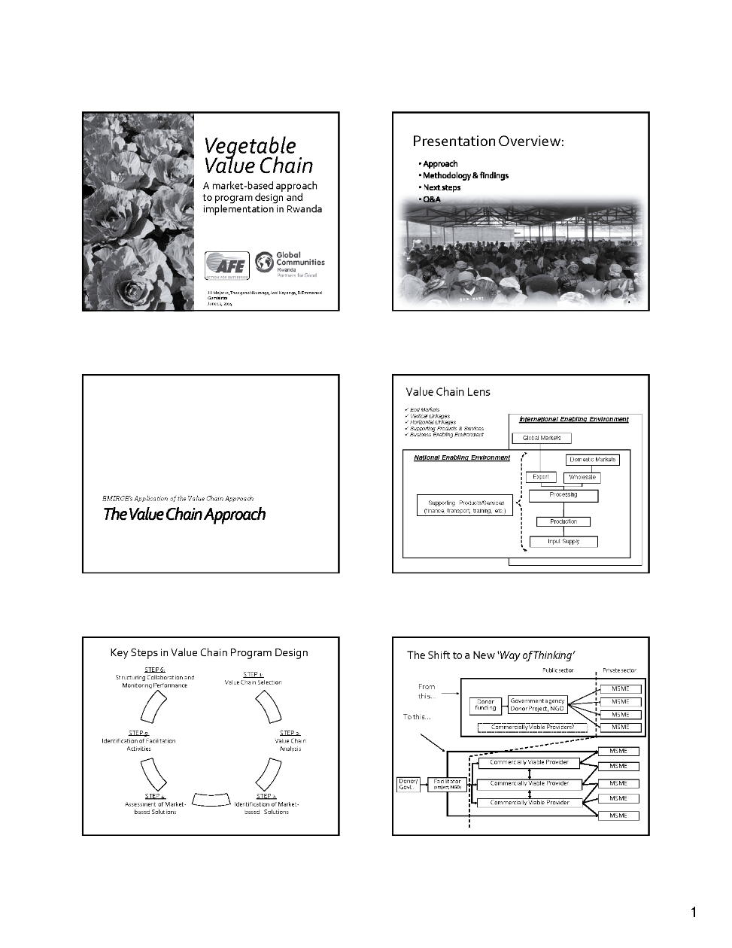

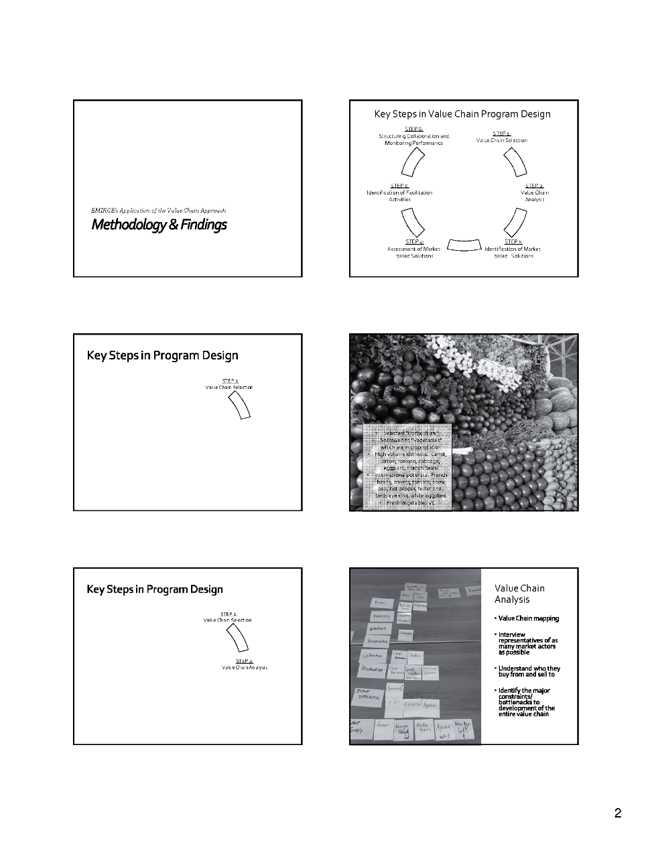

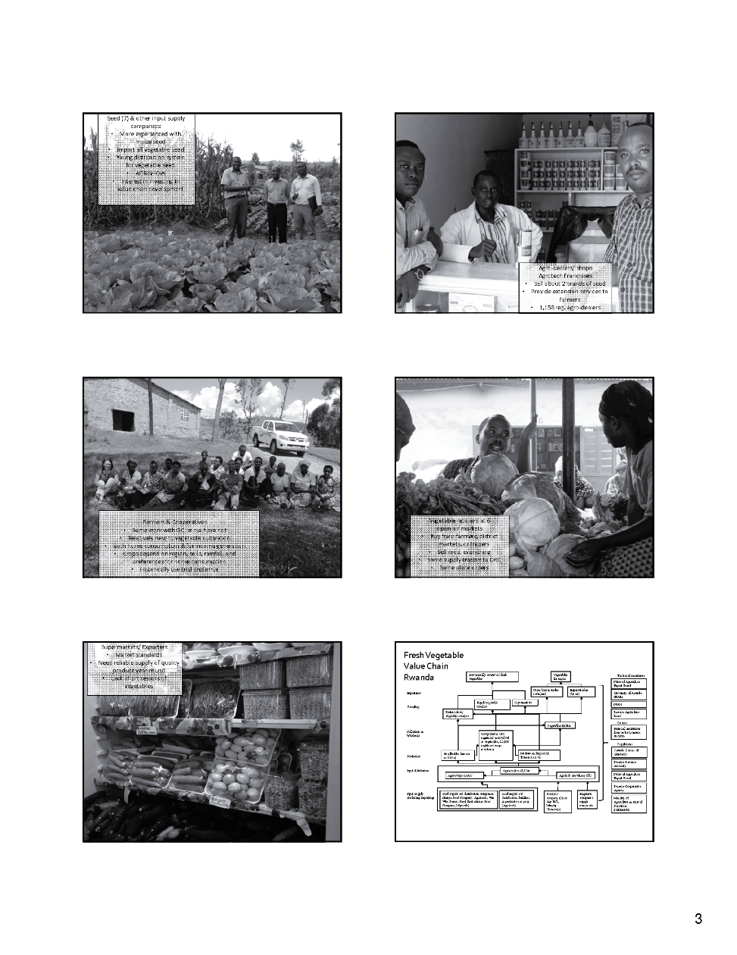

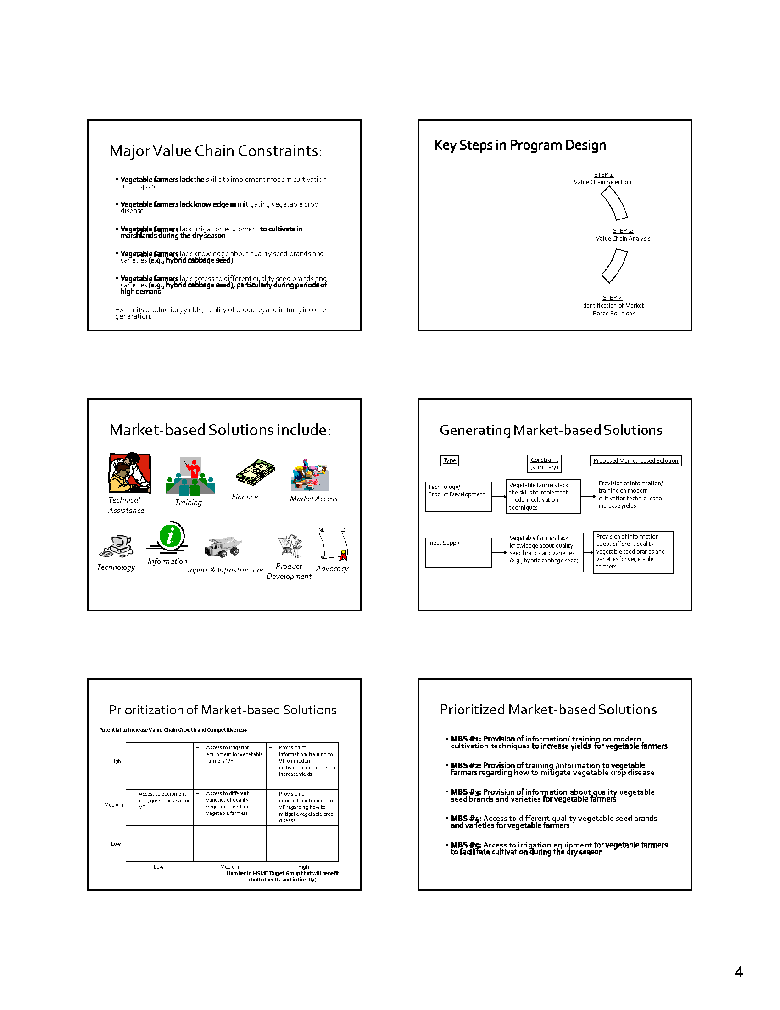

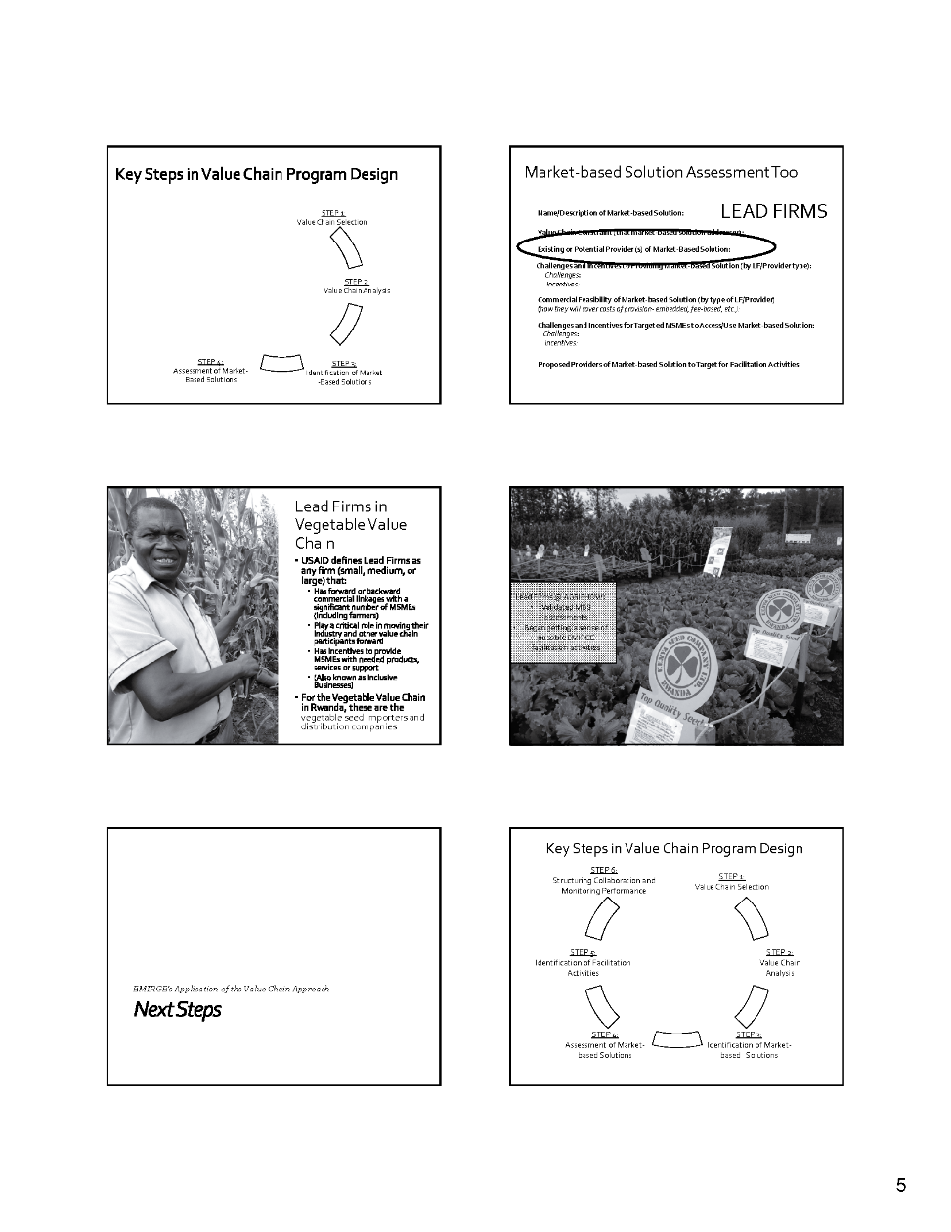

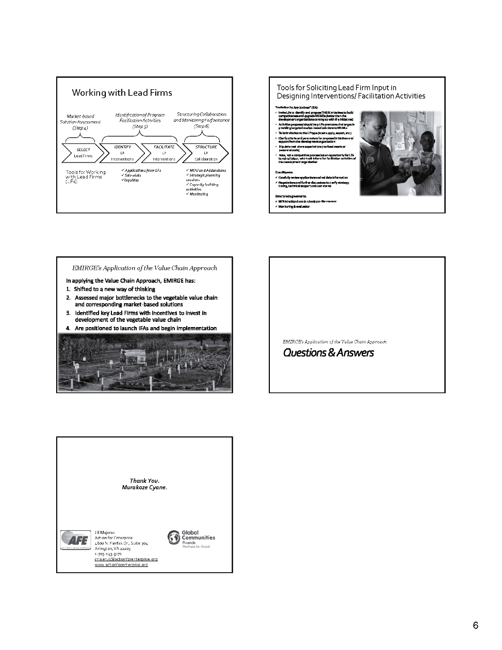

## Appendix 3: Illustrative Work Plan for EMIRGE

|  |  |  |  |  |  |  |  |  |  |  |  |  |  |  |  |
| --- | --- | --- | --- | --- | --- | --- | --- | --- | --- | --- | --- | --- | --- | --- | --- |
| **RECOMMENDED ACTIVITIES FOR RWANDAN FRESH VEGETABLE VALUE CHAIN** | | **WEEKS** | | | | | | | | | | | | **KEY QUESTIONS TO BE ANSWERED** | |
| **1** | **2** | **3** | **4** | **5** | **6** | **7** | **8** | **9** | **10** | **11** | **12** | |  |
| **Determination of Key Program Details** | | | | | | | | | | | | | | | |
| 1 | Determine number of desired lead firms (LFs) |  |  |  |  |  |  |  |  |  |  |  |  | | Will the VC program target only vegetable seed companies or other market actors as well? |
| 2 | Determine EMIRGE VC Program timeline |  |  |  |  |  |  |  |  |  |  |  |  | | When should LF activities begin?  When do LF activities need to be finalized? |
| **Lead Firm Application Process** | | | | | | | | | | | | | | | |
| 1 | Complete the final Invitation for Application (IFA) |  |  |  |  |  |  |  |  |  |  |  |  | |  |
| 2 | Distribute IFAs to potential LFs that were interviewed |  |  |  |  |  |  |  |  |  |  |  |  | |  |
| 3 | Advertise a request for Expressions of Interest (EOIs) through professional networks and/or media to reach all potential LFs |  |  |  |  |  |  |  |  |  |  |  |  | |  |
| 4 | Distribute IFAs to all potential LFs that submit an EOI |  |  |  |  |  |  |  |  |  |  |  |  | |  |
| 5 | Develop Question Guides and review with LFs, as needed |  |  |  |  |  |  |  |  |  |  |  |  | |  |
| **Program Implementation Activities\*** | | | | | | | | | | | | | | | |
| 1 | Receive applications from potential LFs and begin reviewing |  |  |  |  |  |  |  |  |  |  |  |  | | Is there a strong end market for the LFs product of service?  What are the incentives of LFs to conduct the initiative?  How many MSMEs will benefit? How will they benefit?  What is the relationship between the LF and targeted MSMEs? is this relationship sustainable? Are all criteria stipulated in the IFA met? |
| 2 | Coordinate a time to meet with LF representatives to discuss any questions about the application |  |  |  |  |  |  |  |  |  |  |  |  | |  |
| 3 | Conduct site visits and complete due diligence |  |  |  |  |  |  |  |  |  |  |  |  | |  |
| 4 | Draft and negotiate MOUs |  |  |  |  |  |  |  |  |  |  |  |  | |  |
| 5 | Draft and negotiate the initial MOU addendum |  |  |  |  |  |  |  |  |  |  |  |  | |  |
| 6 | Begin facilitation of LF initiative(s) based on the timeline established in the MOU addendum |  |  |  |  |  |  |  |  |  |  |  |  | |  |

*Due diligence should be done throughout the IFA and MOU process to ensure that any issues may be dealt with as early as possible.

## Appendix 4: Draft Invitation for Applications (IFA)

**INVITATION FOR APPLICATIONS**

**PROGRAM TO SUPPORT AGRICULTURAL INPUT SUPPLY**

**IN THE maize and fresh vegetable SECTORs**

***Global Communities*** is an international development organization implementing the ***Enabling Market Integration through Rural Group Empowerment (EMIRGE) Project***. The goal of EMIRGE is to increase incomes of agriculture producers and to improve and expand their businesses in Rwanda by enabling them to overcome common constraints and access skills and opportunities to pursue market driven business objectives.

The EMIRGE team has recently conducted an assessment of the maize and fresh vegetable[11] sectors. The assessment found that that: 1) improved access to quality maize and vegetable seeds, and; 2) improved access to information about the benefits and proper use of these seeds, would dramatically impact smallholder farmer livelihoods in Rwanda.

EMIRGE is therefore inviting agricultural input supply companies in Rwanda to submit applications to develop or expand their capacity to produce and/or sell affordable and quality maize and/or vegetable seed to smallholder farmers. Geographic preference includes, but is not limited to, the following districts: Nyagatare, Nyarugenge, Kamonyi, Ruhango, Nyaruguru, Gicumbi, Rulindo, Gakenke, and Rubavu.

Technical and financial support agreements (with cost share components ranging from $2,500 to $7,500 USD) will be negotiated to pilot specific activities with selected companies based on the selection process described below. This support must contribute to a significant investment (in cash and/or in-kind) that the companies will make. EMIRGE program staff will also provide technical support as needed to build the capacity of successful applicants to implement their proposed initiatives.

Applications must be submitted in accordance with the format described, and received no later than August 31st, 2014.

***Background***

The objective of this EMIRGE program is to support private sector input supply companies in the vegetable and/or maize sectors to build their capacity to provide:

1. greater commercial access to quality vegetable and/or maize[12] seeds to small-holder farmers (less than 0.5 hectares), and;
2. training and/or information to smallholder farmers about the benefits and proper use of quality vegetable and/or maize seeds (including effective production and crop disease mitigation).

EMIRGE realizes the importance of private sector companies to drive change and provide needed inputs and technical support to the producers with whom they transact. EMIRGE is therefore seeking to collaborate with input supply companies to support initiatives that will improve their competitiveness, expand their distribution networks, build their capacity to provide useful information and training to producers, and offer a greater variety of quality inputs adapted to the needs of producers.

***Illustrative Areas for Support***

Proposed initiatives should contribute to the company’s ability to develop and market improved agricultural inputs to smallholder vegetable and/or maize producers. The company will be responsible for organizing and managing the proposed activities, with technical and/or financial support provided by EMIRGE. Examples of initiatives that could be supported include, **but are not limited to**, the following:

1. Company led training, coaching or field days to expose producers, agro-dealers, shops, etc. to improved use of agricultural inputs (seeds, tools, equipment, etc.) and modern cultivation techniques (including disease mitigation);
2. Meetings with maize and/or fresh vegetable processing and export companies to develop a greater understanding of their specific end market requirements (*so that input supply companies can adapt inputs accordingly*).
3. Organization of demonstration plots to expose producers to new varieties and/or improved use of agricultural inputs;
4. Capacity building of company staff to provide improved information and training to producers and distributors;
5. Training and capacity building of product distributors (retailers, franchises, commissioned agents, etc.) to enable them to better inform producers on the correct use the products that the company is offering;
6. Development of posters, brochures or other materials to assist in disseminating correct use of the companies’ agricultural inputs for small-holder farmers;
7. Identification and testing of new crop varieties and other agricultural input products;
8. Development of seed multiplication programs;
9. Developing or improving products to make them more attractive to producers (better packaging, lower cost, enhanced displays, etc.);
10. Exposure visits in Rwanda or other countries to identify new sources of seed, tools, equipment, or other inputs;
11. Expansion of distribution networks through agro-dealer/shop incentive program development, feasibility study for market expansion, assessment of pricing strategies at wholesale and retail levels, and improvements to order placement systems;
12. Strategic planning exercises/ development of business plans to expand distribution networks or develop new products.

This list is non-exhaustive. It is simply to provide examples of company initiatives that could be supported by EMIRGE. Any combination of these activities is encouraged. However, all supported activities must show how they will create sustainable impact for producers that the company sells to.

***EMIRGE cost share funds cannot be used for:***

* Working capital (day to day company operations for salaries, rent, purchases, etc.)
* Direct payment or subsidy to producers
* Fixed assets (tools, equipment, etc.)

***General Criteria***

Eligible Vegetable Input Supply companies must:

* be registered by Rwanda government authorities to sell vegetable seed.
* have been in operation selling vegetable seed for at least one year.
* have distribution systems that extend to agro-dealers, shops or franchise seed vendors in at least 5 districts.
* have sold to at least 200 Rwandan farmers in the past year, either directly or through distribution networks.
* have commercial interest and incentives to invest in extending products and services to Rwandan vegetable farmers, with preference given to the following districts: Nyagatare, Nyarugenge, Kamonyi, Ruhango, Nyaruguru, Gicumbi, Rulindo, Gakenke, and Rubavu.
* have policies in place to ensure that no dangerous or illegal products are sold to farmers.
* make an investment of at least 30% of the cost of the proposed initiatives.
* be willing to share activity and sales information relative to cost-shared endeavors.
* ***propose initiatives where at least 60% of budget is for activities that involve direct support to producers (training, field days, introduction of new products, technologies, quality management, etc.)***

Eligible Maize Input Supply companies must:

* be registered by Rwanda government authorities to produce and/or sell maize seed.
* have been in operation for at least one year.
* have commercial interest and incentives to invest in extending products and services to Rwandan maize farmers, with preference given to the following districts: Nyagatare, Nyarugenge, Kamonyi, Ruhango, Nyaruguru, Gicumbi, Rulindo, Gakenke, and Rubavu.
* have policies in place to ensure that no dangerous or illegal products are sold to farmers.
* make an investment of at least 30% of the cost of the proposed initiatives.
* be willing to share activity and sales information relative to cost-shared endeavors.
* ***propose initiatives where at least 60% of budget is for activities that involve direct support to producers (training, field days, introduction of new products, technologies, quality management, etc.)***

*Note: NGOs, government agencies, cooperatives, consulting firms, and associations are not eligible to apply.*

After review of the applications, EMIRGE may determine that some of the proposed initiatives (such as exposure visits) might be best pursued as “cross-company” interventions, with several agricultural input supply companies participating. This could have the effect of reducing costs and promoting lateral learning among the participating companies. This assessment (as well as discussions with the Applicants) will take place once companies have submitted their applications.

***Expected Results***

While it is expected that participating companies will benefit from these activities, it is also expected that activities supported under this program will benefit the producers the companies are selling to in terms of better information, skills upgrading, improved productivity, enhanced revenues, etc. as well as improving their ability to sell maize and fresh vegetables to traders, processing and export companies in Rwanda.

***Preparation of Applications***

Support from EMIRGE may be given to several different companies. All applications will be evaluated based on the criteria in the table below and the general criteria given above. ***All applicants that meet the criteria will be considered for support.*** Applicants are encouraged to discuss their ideas and request advice from EMIRGE in the preparation of their applications.

**INSTRUCTIONS AND FORMAT**

|  |
| --- |
| **Cover Page**  *Name and Address of Applicant (address, phone, fax, email)*  *Date of Submission*  *Lead Person to Contact* |
| **Company background (up to 1 page):**  *Provide company information such as number of years in operations, number of employees, and licenses in Rwanda related to proposed activities.*  *Provide description of existing distribution system, including list of districts distributing to at present.* |
| **Activities and Impact (up to 2 pages)**:  *Clear description of proposed activities including how they fit into the company’s business strategy, how they will contribute to improved competitiveness, and how they will promote greater access to quality inputs and/or provide information/ training regarding modern cultivation techniques for producers.* |
| **Personnel (up to 1/2 page):**  *Describe the name and qualifications of the people who will be responsible for implementing the activities.* |
| **Experience (up to 1/2 page):**  *Brief description of past or current initiatives that company has conducted similar to those proposed, or why the company feels it is qualified to successfully conduct the proposed activities.* |
| **Sustainability (up to ½ page):**  *A clear description of how the activities will result in increased and sustainable commercial relationships between the company, its distributors, and producers, and how the company will be able to continue these commercial relationships and provide ongoing support to the producers once the program ends.* |

Applications will be accepted in English and Kinyarwanda (though English is preferred) and must be no more than five pages in length (excluding cover page and budget or budget notes). EMIRGE will select applicants that meet criteria by September 19, 2014. At that time, more detailed activity planning will take place between EMIRGE and the applicants. This planning will include:

* Detailed discussions and agreement on strategy, budget and timing for different activities.
* Discussions on how technical support from EMIRGE staff and consultants can be provided to support the agreed upon activities.
* Discussions on how combined technical support or “cross-company activities” might be organized with several companies.

All supported initiatives must be completed within a year of signing an agreement with EMIRGE.

Please submit an electronic copy of the application by August 31st, 2014 to the EMIRGE representative at email: tnkuranga@rw.globalcommunities.org. Please include the name of the lead contact person who will be involved with the application process as well as the telephone and email contact information.

Conditions: **Issuance of this request for application in no way constitutes a commitment by EMIRGE to execute any agreement or to pay any costs incurred by any applicant in submitting an application.**

Please note that EMIRGE **will fully respect the confidentiality** of all companies involved in the program. A joint memorandum of understanding between EMIRGE and the Company will be developed, with detailed activities clearly defining the respective responsibilities, roles, and obligations of each party. Successful applicants must be willing to share information with EMIRGE regarding their sales to (or purchases from) targeted producers. EMIRGE (on a sample basis) will conduct interviews with these producers to gather information on impact and to monitor progress.

**Instructions for Completing the Budget**

Each applicant will prepare a budget using the format below. Please provide as much detail as possible in the line item descriptions and budget notes. If possible (though not mandatory) applicant should prepare and send this budget as an additional file in Microsoft Excel format. ***Applicant must contribute at least 30% to proposed costs***.

|  | **Line Item** | **Budget Notes**  **(describes line item**  **in more detail)** | **Cost/ Unit** | **Days/ Unit** | **People/ Number** | **Total Cost** | **Company Investment** | **EMIRGE cost share** |
| --- | --- | --- | --- | --- | --- | --- | --- | --- |
| 1 |  |  |  |  |  |  |  |  |
| 2 |  |  |  |  |  |  |  |  |
| 3 |  |  |  |  |  |  |  |  |
| 5 |  |  |  |  |  |  |  |  |
| 6 |  |  |  |  |  |  |  |  |
| 7 |  |  |  |  |  |  |  |  |
| 8 |  |  |  |  |  |  |  |  |
| 9 |  |  |  |  |  |  |  |  |
| 10 |  |  |  |  |  |  |  |  |
| 11 |  |  |  |  |  |  |  |  |
|  |  |  |  |  |  |  |  |  |
|  | **EMIRGE cost share (up to 70%)** |  |  |  |  |  |  |  |
|  | **Company cost share (at least 30%)** |  |  |  |  |  |  |  |

***\* Please contact EMIRGE for any assistance or questions you may have***

## Appendix 5: Interview Guide for Lead Firms

**Interview Guide for Lead Firms**

*(Providers of the targeted market-based solution (MBS))*

**Introduction**

We represent the _________________ project. We have conducted research into the ________ industry and have found that *[name of market-based solution]* is a constraint facing many *[targeted MSMEs].* We are here to follow up with this issue and try to understand what the problems are and what can be done to address them. We are hoping you can help us to do this. The ____________ project will be developing a program of support to the *[name of Value Chain]* sector and this information will be useful in developing this program. Depending on the results of the program design, firms like yours could be invited to participate.

This illustrative guide should serve as checklist to ensure that questions are addressed in interviews with LFs. It **should not be used as a questionnaire**. It will need to be adapted to the specific context or entry point that the Development Organization has for working with LFs.

**Part I: General company information, position in value chain, competitive advantage, etc.**

| **Company Name and Contact Information** |
| --- |
| Description of products or services they sell |
| Description of market trends and demand for their products or services |
| Geographic coverage where they sell their products or services |
| Company size and number of staff |
| Years in business |
| What differentiates your firm from your competition? What is your unique selling point or strength? |
| Are you participating in/or a member of any professional associations? Do you participate in any industry forums? |
| Have you made any recent investments to develop or expand your company? |
| Description of how and where the company sources raw materials |
| Supply/distribution map (showing how products or services are sourced and distributed) |
| What types of investments have you made (or are you planning to make) to “upgrade” or strengthen the MSMEs that you buy from or sell to? |
| Description of major constraints affecting your overall business |
| Please list any other companies similar to yours that are in your industry? Which ones have the largest market share? Which are most innovative? |
| Are you currently working with any donors or development organizations? |

**Part II: Specific Information on Product, Service, or Support (Market-Based Solution) that LF Provides (or could provide) to MSMEs they Buy from or Sell to**

| **[Market-Based Solution #1]** | **Questions** |
| --- | --- |
| **General Information** | * How many MSMEs do you currently carry out *[market-based solution][13]* with and where? * Describe the size of these MSMEs and the scale of your transactions with them. |
| **Incentives/ Risks/ Constraints** | * What incentives do you have for carrying out *[market-based solution]* to *[targeted MSMEs]*? * What challenges or risks do you face in carrying out *[market-based solution]* to *[targeted MSMEs]*? * What support do you need to reduce risks or develop capacity to address these challenges? |
| **Description** (diversity of production, features/ benefits, cost recovery, etc.) | * Describe how you conduct *[market-based solution]* to [*targeted MSMEs*]. * How do you cover your costs of carrying out *[direct procurement, sales of inputs, technical support, etc.]* to [*targeted MSMEs*]? * What are the features and benefits (e.g., transport, after sale market solutions, warranties, etc.) that you provide to make *[market-based solution]* more appealing to [*targeted MSMEs*]? * How many firms carry out *[market-based solution]* to [*targeted MSMEs*]? (get contact info) |
| **Users / Trends** | * How many *[targeted MSMEs]* do you carry out *[market-based solution]* for? * How frequently do you carry out *[market-based solution]*? What is the volume or scale of your *[market-based solution]* per year? * How many [*targeted MSMEs*] do you think can use (and acquire/pay for) the *[market-based solution]*? * Do you see the need for *[market-based solution]* growing in the future? * How do/will you obtain information on what *[targeted MSMEs]* want? * How do/will you let *[targeted MSMEs]* know that you carry out *[market-based solution]?* |

**Part III: Describe any initiatives you would like to carry out to improve or expand your capacity to provide *[market-based solution]* to the *[type of MSMEs]* you buy from or sell to**

1. Limited to marshlands and/or near Musanze where year-round rainfall provides adequate irrigation.
2. Figures varied by source; presenting most conservative figure.
3. Figures varied by source; presenting most conservative figure.
4. Can be used if for less than 2 ha; Irrigating 1 ha by hand would take 8 man hours, but with pedal pump it would take 2.5 hours.
5. Necessary for more than 2 ha (for 3 – 5 ha, can use 5 horsepower pump)
6. Registered with Rwanda Cooperative Agency (RCA).
7. Rankings refer to short-listing matrix criteria (see following section; H = high, M = medium, and L = low) which were Potential to Increase Value Chain Growth and Competitiveness and Number of Vegetable Farmers that will benefit (both directly and indirectly), respectively
8. Key informants stated that some farmers can read Kinyarwanda while few, if any, farmers can read English.
9. ““Tools & Methodologies for Collaborating with Lead Firms: A Practitioner’s Manual”. 2014. Action For Enterprise. <http://www.actionforenterprise.org/lf-manual.pdf>
10. *Smart subsidies can be defined as those that encourage LFs to do something they probably would not be doing on their own, at least not right away because they see it as too risky. DO value is in buying down that risk to a reasonable level with a reasonable degree of subsidy without doing the work for them or creating dependency on the DO to drive the process.*
11. Carrot, onion, tomato, cabbage, purple and white eggplant, and French beans
12. In the case of maize seed industry, EMIRGE’s objective is to support companies to prepare for the planned transition of market responsibilities from Rwandan government agencies to private sector companies.
13. Insert MBS such as procurement (access to markets), sale of seeds, provision of technical support, etc.